**1_Introduction_and_Recap**

**Introduction**

Hello, and welcome. My name is Dimitri, and I'm happy to see you are interested in competitive data science. Data science is all about machine learning applications. And in data science, like everywhere else, people are looking for the very best solutions to their problems. They're looking for the models that have the best predictive capabilities, the models that make as few mistakes as possible. And the competition for one becomes an essential way to find such solutions. Competing for the prize, participants push through the limits, come up with novel ideas. Companies organize data science competitions to get top quality models for not so high price. And for data scientists, competitions become a truly unique opportunity to learn, well, and of course win a prize.

This course is a chance for you to catch up on the trends in competitive data science and learn what we, competition addicts and at the same time, lecturers of this course, have already learned while competing.

In this course, we will go through competition solving process step by step and tell you about exploratory data analysis, basic and advanced feature generation and preprocessing, various model validation techniques. Data leakages, competition's metric optimization, model ensembling, and hyperparameter tuning. We've put together all our experience and created this course for you. We've also designed quizzes and programming assignments to let you apply your newly acquired skills. Moreover, as a final project, you will have an opportunity to compete with other students and participate in a special competition, hosted on the world's largest platform for data science challenges called Kaggle. Now, let's meet other lecturers and get started.

**Welcome**

Welcome to “How to win a data science competition” course! We are excited to have you in the class and we are looking forward to your contributions to the learning community.

Among all topics of data science, competitive data analysis is especially interesting. For an experienced specialist this is a great area to try his skills against other people and learn some new tricks; and for a novice this a good start to quickly and playfully learn basics of practical data science. For both, engaging in a competition is a good chance to expand the knowledge and get acquainted with new people.

But, despite that competitive data analysis is useful for both experts and novices, this particular course is designed for advanced students: while we teach ABC of data science competitions, we assume you are already familiar with machine learning ABC. If you only begin your journey in data science, we encourage you to check out other machine learning courses on Coursera. If you are familiar with python, sklearn and already have some experience in training machine learning models, we hope this course will prove useful to you.

As in any competitive field, you need to work very hard to get a prize in a competition. But you also need to work efficiently -- you need to develop an intuition and be able to quickly determine how it is best to approach a given competition -- how to preprocess the data, extract features, how to set up the validation correctly and optimize the given metric. You should know the potential sources of data leakages, what parameters to tune in your favorite models, how to generate powerful features, how to ensemble the models. This is just an essential checklist, that every top data scientist should know. Beyond that, every new competition requires you to craft new techniques and approaches, and as you will go through them, your experience and expertise will grow.

In this course, you will learn the essential techniques, mentioned above. We will also illustrate creativity in solutions with a detailed breakdown of our solutions in a number of competitions, in which the instructors of this course got top places -- a truly unique opportunity to see the detailed explanations of the winning solutions.

Everyone who works hard will learn a lot. But because this is a competition, only the most creative, dedicated and experienced people will be able to outperform others and get to the very top. But still, the obvious truth is, the more time you spend on a competition, the more you will be able to learn.

This course is delivered to you by the people who spent much time competing and mostly learned everything by trials and errors. We started our journey in competitive data science a while back, and were brought together by "Machine Learning Training" meetups in Moscow, which were organized by our common friend in Yandex. We successfully participated in wide range of competitions on Kaggle and other platforms since then, competing, learning and sharing knowledge with many other people. This was really inspiring time when we learned that through collaboration and hard work you can accomplish so much.

We personally are very grateful to Alexander Djakonov, a former top1 at Kaggle, who taught a course on data science and shared a lot of his secrets. His course was a truly exciting journey for us and now this is our time to share our knowledge. Also, we want to specially thank Stanislav Semenov for consulting about study plan, lectures and assignments.

Good luck as you get started and we hope you enjoy the course!

Sincerely yours,

Dmitry Ulyanov, Alexander Guschin, Mikhail Trofimov, Dmitry Altukhov and Marios Michailidis

And now, I want to introduce other lecturers of this course. Alexander, Dmitry, Mikhail, and Marios. Mikhail is aka Cassanova, the person who reached the very top of competitive data science. I will tell you a couple of thoughts about the origins of the course. In year 2014, we started our win in data science by joining competitions. We've been meeting every week and discussing the past competitions, solutions, ideas and tweaks what worked and what did not, this exchange of knowledge and experience helped us to learn quickly from each other and improve our skills. Initially our community was small, but over time more and more people were joining. From the format of groups of discussion. We moved on to the format of well organized meetings. Where a speaker makes an overview of his approach and ideas in front of 50 people. These meetings are called machine learning trainings. Now with the help and support of Yandex and get a hundred of participants. Thus we started from zero and learned everything by hard work and collaboration. We had an excellent teacher, Alexander D'yakonov who was top one on Kaggle, he took the course on critical data analysis. In Moscow state university and there we're grateful to him. At some point we started to share our knowledge with other people and some of us even started to read lectures at the university. So now we have decided to summarize everything and make it available for everyone. Together. We've finished and procesed in about 20 different competitions only on Kaggle and just as many on other not so famous platforms. All of us have a tremendous amount of skill and experience in competitive data science and now we want to share this experience with you. For all of us, competitive data science opened a number of opportunities as the competitions we took part were dedicated to a large variety of tasks. Mikhail works in e-commerce. Alexander builds predictive model for taxi services, Dmitri works with financial data, Mario develops machinery learning frameworks and I am a deep learning researcher. Competitions, without a doubt, became a stepping stone for our careers and believe me, good comparative record will bring success to you as well. We hope you will find something interesting in this course and wish you good luck.

**Meet your lecturers**

And now, I want to introduce other lecturers of this course. Alexander, Dmitry, Mikhail, and Marios. Mikhail is aka Cassanova, the person who reached the very top of competitive data science. I will tell you a couple of thoughts about the origins of the course. In year 2014, we started our win in data science by joining competitions. We've been meeting every week and discussing the past competitions, solutions, ideas and tweaks what worked and what did not, this exchange of knowledge and experience helped us to learn quickly from each other and improve our skills. Initially our community was small, but over time more and more people were joining. From the format of groups of discussion. We moved on to the format of well organized meetings. Where a speaker makes an overview of his approach and ideas in front of 50 people. These meetings are called machine learning trainings. Now with the help and support of Yandex and get a hundred of participants. Thus we started from zero and learned everything by hard work and collaboration. We had an excellent teacher, Alexander D'yakonov who was top one on Kaggle, he took the course on critical data analysis. In Moscow state university and there we're grateful to him. At some point we started to share our knowledge with other people and some of us even started to read lectures at the university. So now we have decided to summarize everything and make it available for everyone. Together. We've finished and procesed in about 20 different competitions only on Kaggle and just as many on other not so famous platforms. All of us have a tremendous amount of skill and experience in competitive data science and now we want to share this experience with you. For all of us, competitive data science opened a number of opportunities as the competitions we took part were dedicated to a large variety of tasks. Mikhail works in e-commerce. Alexander builds predictive model for taxi services, Dmitri works with financial data, Mario develops machinery learning frameworks and I am a deep learning researcher. Competitions, without a doubt, became a stepping stone for our careers and believe me, good comparative record will bring success to you as well. We hope you will find something interesting in this course and wish you good luck.

**Course overview**

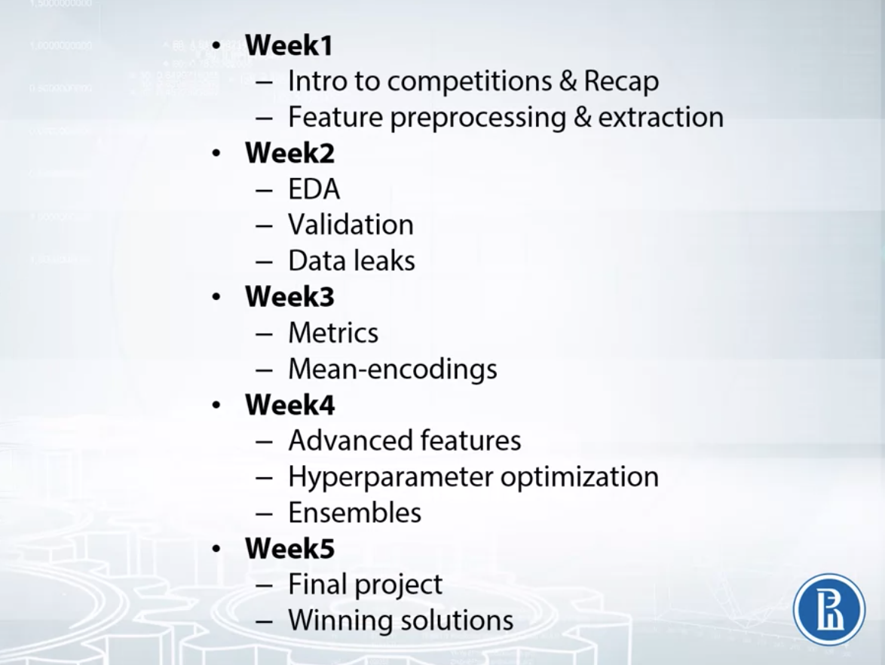

Hello and welcome to our course. In this video, I want to give you a sense for what this course is about and I think the best way to do that is to talk about our course goals, our course assignments and our course schedule. So, at the broadest level, this course is about getting the required knowledge and expertise to successfully participate in data science competitions. That's the goal. Now, we're going to prepare this in a systematic way. We start in week one with a discussion of competitions, what are they, how they work, how they are different from real-life industrial data analysis. Then, we're moving to recap of main machine learning models. Besides this, we're going to review software and hardware requirements and common Python libraries for data analysis. After this is done, we'll go through various feature types, how we preprocess these features and generate new ones. Now, because we sometimes need to extract features from text and images, we will elaborate on most popular methods to do it. Finally, we will start working on the final project, the competition. But then we move on to week two. So, having figured out methods to work with data frames and models, we're starting to cover things you first do in a competition. And this is, by the way, a great opportunity to start working on the final project as we proceed through material. So, first in this week, we'll analyze data set in the exploratory data analysis topic or EDA for short. We'll discuss ways to build intuition about the data, explore anonymized features and clean the data set. Our main instrument here will be logic and visualizations. Okay, now, after making EDA, we switch to validation. And here, we'll spend some time talking about different validation strategies, identifying how data is split into train and test and about what problems we may encounter during validation and ways to address those problems. We finish this week with discussion of data leakage and leaderboard problem. We will define data leakage and understand what are leaks, how to discover various leaks and how to utilize them. So basically, this week, we set up the main pipeline for our final project. And at this point, you should have intuition about the data, reliable validation and data leaks explored. After this pipeline is ready, we'll focus on the improvement of our solution and that's already the week three. In that week, we'll analyze various metrics for regression and classification and figure out ways to optimize them both while training the model and afterwards. After we will check that we are correct in measure and improvements of our models, we'll define mean-encodings and work on the encoded features. So here, we start with categorical features, how mean-encoded features lead to overfitting and how we balance overfitting with regularization. Then, we'll discuss several extensions to this approach including applying mean-encodings to numeric features and time series, and this is the point where we move on to other advanced features in the week four. Basically, this include statistics and distance-based features, metrics factorizations, feature interactions and t-SNE. These features often are the key to superior performance in competition, so you should implement and optimize them here for the final project. After this, we'll get to hyperparameters optimization. Here, we will revise your knowledge about model tuning in a systematic way and let you apply to the competition. Then, we move onto the practical guide where all of us have summarized most important moments about competitions which became absolutely clear after few years of participation. These include both some general advice on how to choose and participate in the competition and some technical advice, how to set up your pipeline, what to do first and so on. Finally, we'll conclude this week by working on ensembles with KazAnova, the Kaggle top one. We'll start with simple linear ensemble, then we continue with bagging and boosting, and finally we'll cover stacking and stacked net approach. And here by the end of this week, you should already have all required knowledge to succeed in a competition. And then finally, we've got the last week. Here we will work to analyze some of our winning solutions in competitions. But all we are really doing in the last week is wrapping up the course, working on and submitting the final project. So, this basic structure of this course. Now, we move through those sections so that you can practice your skills in the course assignments and there are three basic types of assignments in this class: quizzes, programming assignments and the final project. You don't have to do all of these in order to pass the class, you only need to complete the required assignments and you can see which ones those are by looking on the course website. But let's go ahead and talk about the assignments. We begin with the competition. This is going to be the main assignment for you. In fact, we start working on it on the week two. There we do EDA, exploratory data analysis, set up main pipeline that you'll use for the rest of the course and check the competition for leakages. Then in week three we update our solution by optimizing given metric and adding mean-encoded features. After that, in the week four, we further improve our solution by working on advanced features, tune your hyperparameters and uniting models in ensemble. And in last week, we all are wrapping it up and producing solution by Kaggle winning model standards. We ask you to work on the project at your local machine or your server because Coursera computational resources are limited, and using them for the final project can slow down completing programming assignments for the fellow students. And, in fact, this class is mostly about this program and this competition assignment, but we also have quizzes and programming assignments for you. We include these to give you an opportunity to refine your knowledge about specific parts of this course: how to check data for leakages, how to implement mean encodings, how to produce an ensemble and so on. You can do them at Coursera site directly but you also can download these notebooks and complete them at your local computer or your server. And this basically is an overview of the course goals, course schedule and course assignments. So, let's go ahead and get started.

**Week 1 overview**

Welcome to the first week of the "How to Win a Data Science Competition" course! This is a short summary of what you will learn.

Mikhail Trofimov will introduce you to competitive data science. You will learn about competitions' mechanics, the difference between competitions and a real-life data science, overview hardware and software that people usually use in competitions. We will also briefly recap major ML models frequently used in competitions.

Alexander Guschin will summarize approaches to work with features: preprocessing, generation and extraction. We will see, that the choice of the machine learning model impacts both preprocessing we apply to the features and our approach to generation of new ones. We will also discuss feature extraction from text with Bag Of Words and Word2vec, and feature extraction from images with Convolution Neural Networks.

Let's go ahead and get started!

**Competition Mechanics**

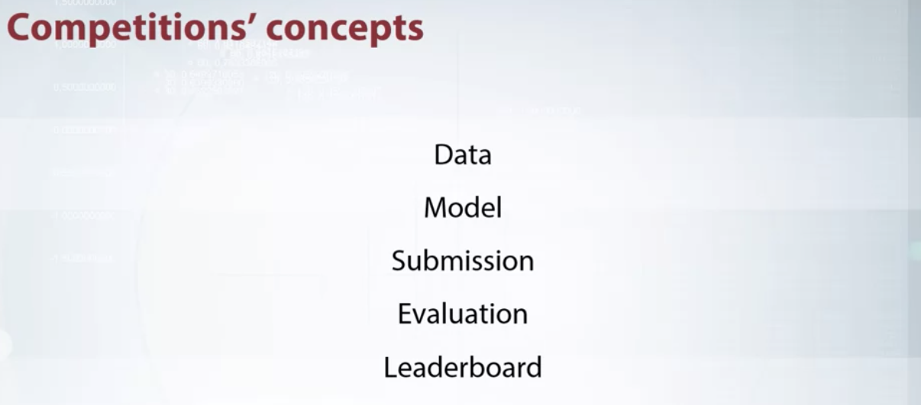

Hi everyone. We are starting course about machine learning competitions. In this course, you will learn a lot of tricks and best practices about data science competitions. Before we start to learn advanced techniques, we need to understand the basics. In this video, I will explain the main concept of competitions and you will become familiar with competition mechanics. A variety of machinery competition is very high. In some, participants are asked to process texts. In others, to classify picture or select the best advertising. Despite the variety, all of these competitions are very similar in structure. Usually, they consist of the same elements or concepts which we will discuss in this video.

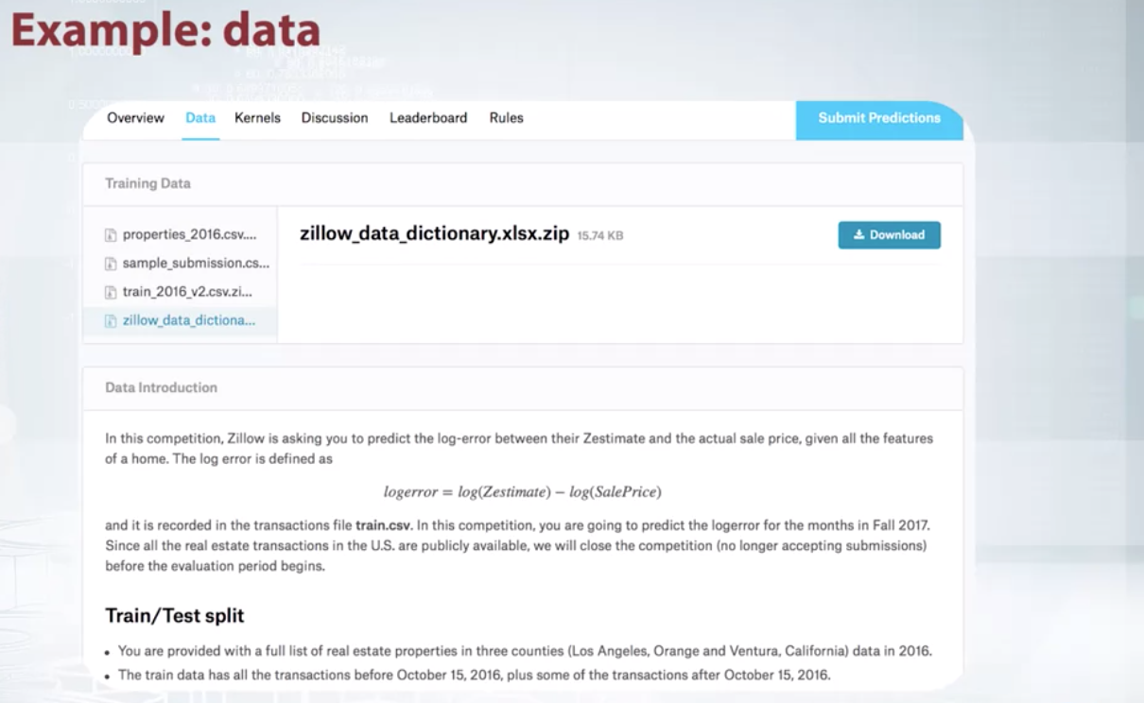

Let's start with a data. Data is what the organizers give us as training material. We will use it in order to produce our solution. Data can be represented in a variety of formats. SSV file with several columns , a text file, an archive with pictures, a database dump, a disabled code or even all together. With the data, usually there is a description. It's useful to read it in order to understand what we'll work with and which feature can be extracted. Here is an example from Kaggle. From the top, we see several files with data, and below, is their description. Sometimes in addition to data issued by organizers, we can use other data. For example, in order to improve image classification model, one may use a publicly available data set of images. But this depends on a particular competition and you need to check the rules.

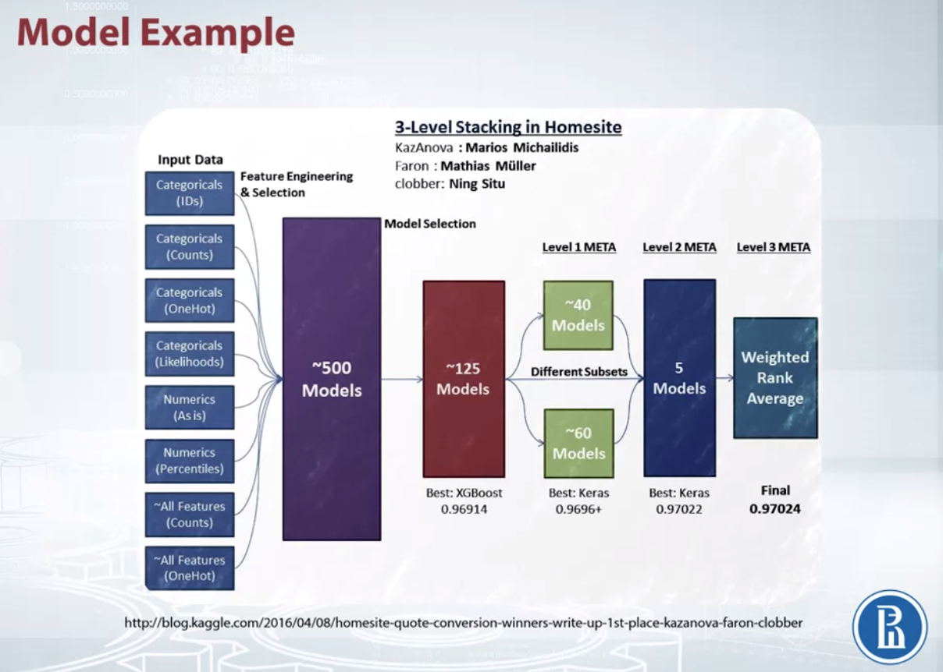

The next concept is a model. This is exactly what we will build during the competition. It's better to think about model not as one specific algorithm, but something that transforms data into answers. The model should have two main properties. It should produce best possible prediction and be reproducible. In fact, it can be very complicated and contain a lot of algorithms, handcrafted features, use a variety of libraries as this model of the winners of the Homesite competition shown on this slide. It's large and includes many components. But in the course, we will learn how to build such models.

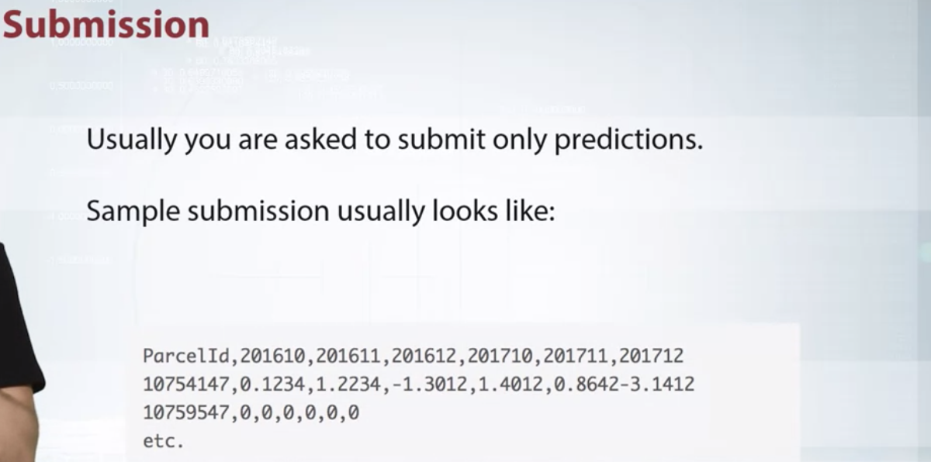

To compare our model with the model of other participants, we will send our predictions to the server or in other words, make the submission. Usually, you're asked about predictions only. Sources or models are not required. And also there are some exceptions, cool competitions, where participants submit their code. In this course, we'll focus on traditional challenges where a competitor submit only prediction outputs. Often, I can not just provide a so-called sample submission. An example of how the submission file should look like, look at the sample submission from the Zillow competition. In it is the first column. We must specify the ID of the object and then specify our prediction for it. This is typical format that is used in many competitions.

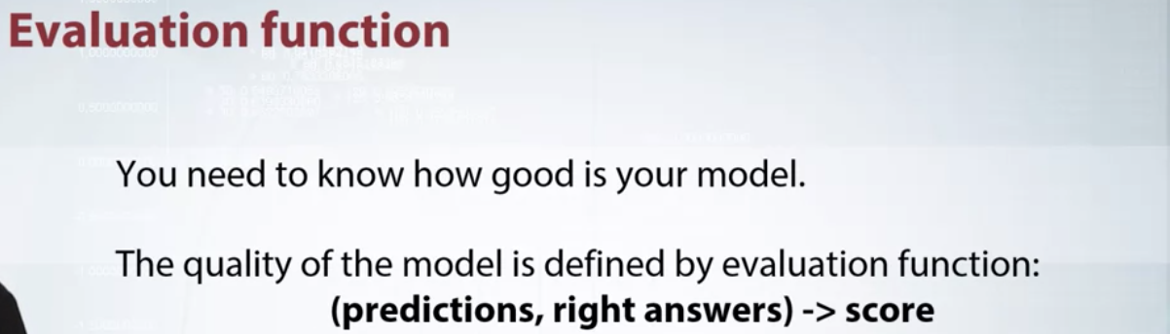

Now, we move to the next concept, evaluation function. When you submit predictions, you need to know how good is your model. The quality of the model is defined by evaluation function. In essence and simply the function, the text prediction and correct answers and returns a score characterizes the performance of the solution. The simplest example of such a function is the accurate score. This is just a rate of correct answers.

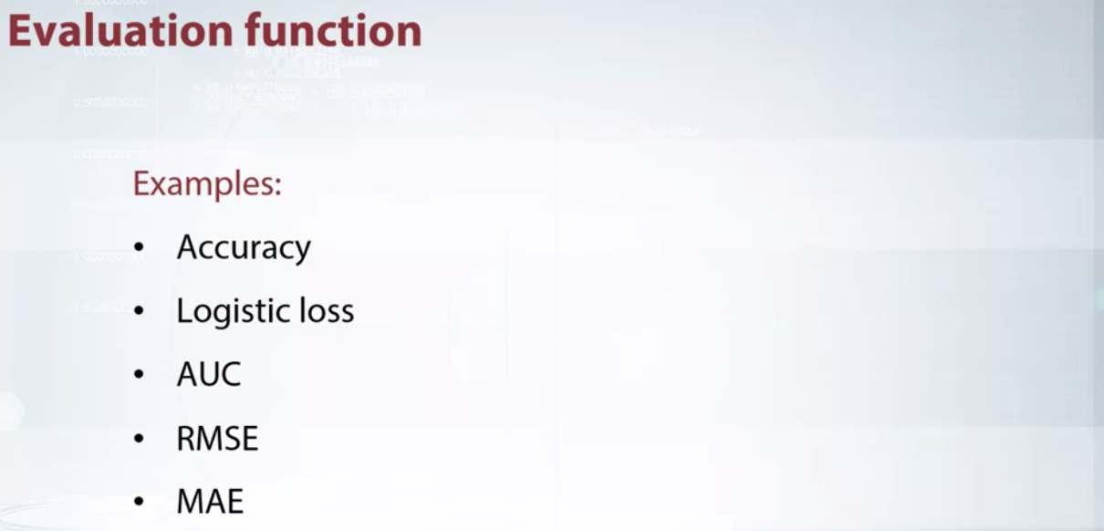

In general, there are a lot of such functions. In our course, we will carefully consider some of them. The description of the competition always indicates which evaluation function is used. I strongly suggest you to pay attention to this function because it is what we will try to optimize.

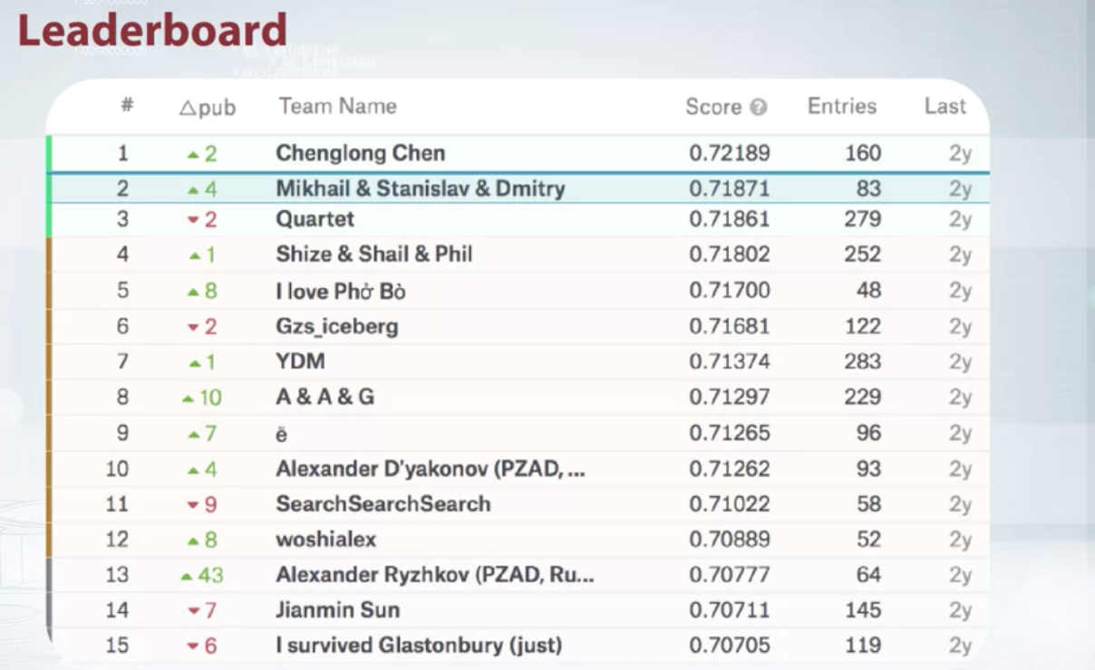

But often, we are not interested in the score itself. We should only care about our relative performance in comparison to other competitors. So we move to the last point we are considering, the leaderboard. The leaderboard is the rate which provides you with information about performance of all participating teams.

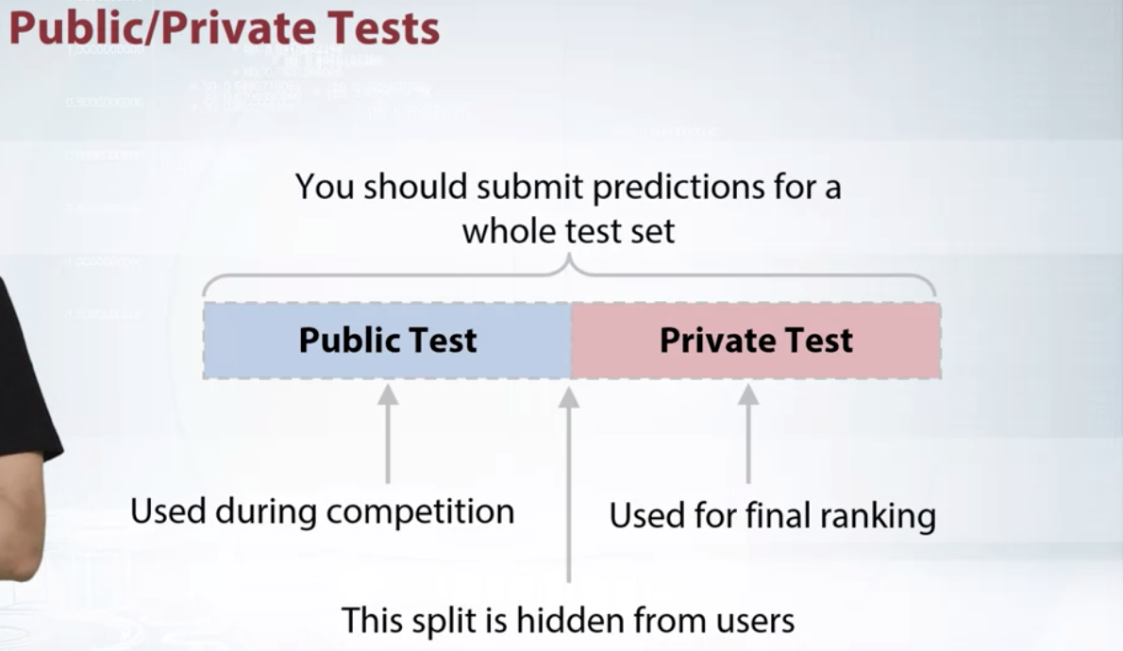

Most machine learning competition platforms keep your submission history, but the leaderboard usually shows only your best score and position. They cannot as that submission score, reveal some information about data set. And, in extreme cases, one can obtain ground truth targets after sending a lot of submissions. In order to handle this, the set is divided into two parts, public and private. This split is hidden from users and during the competition, we see the score calculated only on public subset of the data. The second part of data set is used for private leaderboard which is revealed after the end of the competition. Only this second part is used for final rating.

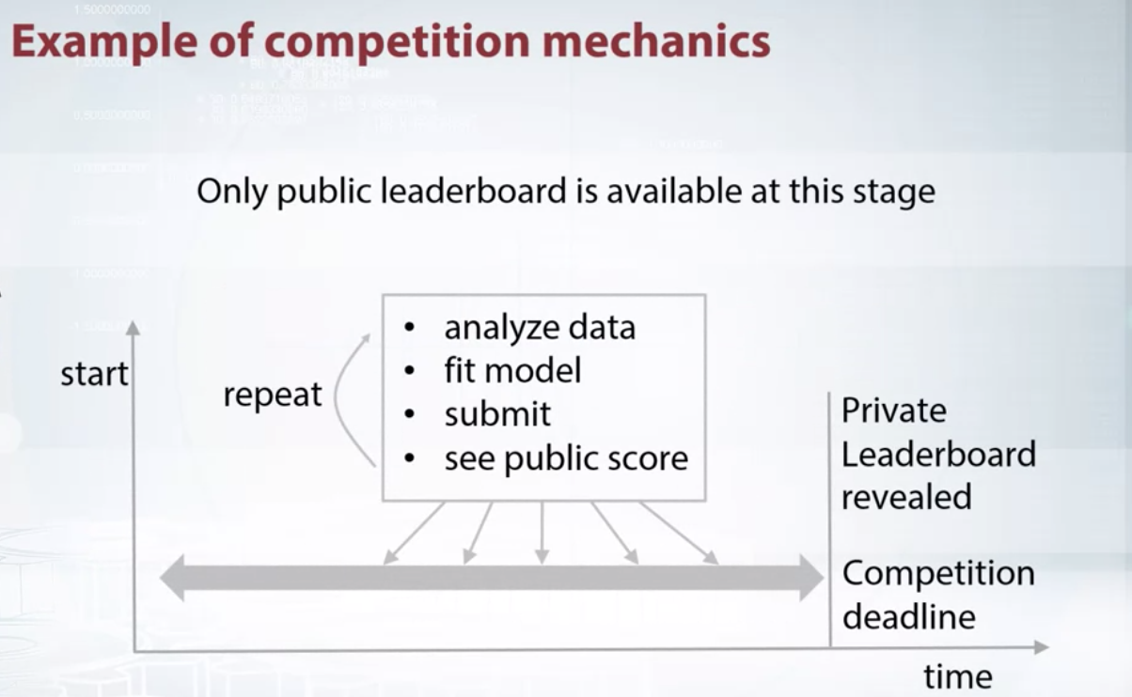

Therefore, a standard competition routine looks like that. You as the competition, you analyze the data, improve model, prepare submission, send it, see leaderboard score. You repeat this action several times. All this time, only public leaderboard is available. By the end of the competition, you should select submissions which will be used for final scoring. Usually, you are allowed to select two final submissions. Choose wisely. Sometimes public leaderboard scores might be misleading. After the competition deadline, public leaderboard is revealed, and its used for the final rating and defining the winners. That was a brief overview of competition mechanics. Keep in mind that many concepts can be slightly different in a particular competition. All details, for example, where they can join into teams or use external data, you will find in the rules. Strongly suggest you to read the rules carefully before joining the competition.

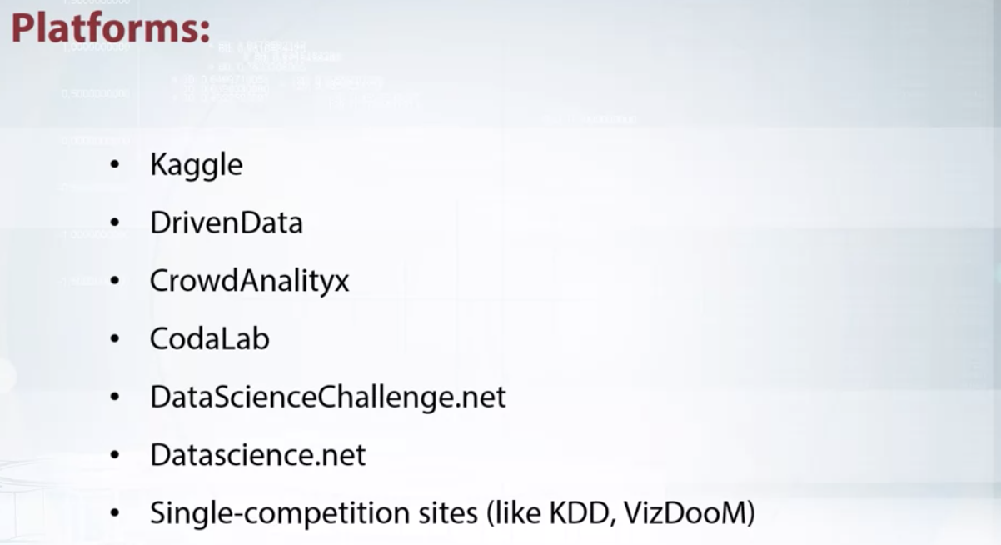

Now, I want to say a few words about competition platforms. Although Kaggle is the biggest and most famous one, there is a number of smaller platforms or even single-competition sites like KDD and VizDooM. Although this list will change over time, I believe you will find the competition which is most relevant and interesting for you.

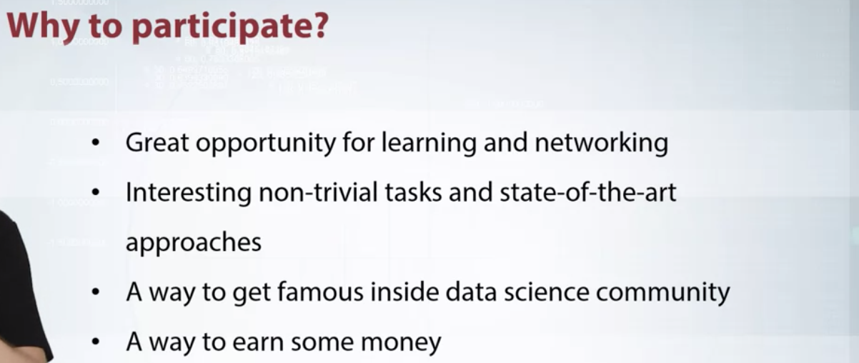

Finally, I want to tell you about the reasons to participate in data science competition. The main reason is that competition is a great opportunity for learning. You communicate with other participants, try new approaches and get a lot of experience. Second reason is that competition often offer you non-trivial problems and state-of-the-art approaches. It allows you to broaden the horizons and look at some everyday task from a different point of view. It's also a great way to become recognizable, get some kind of frame inside data science community and receive a nice job offer. The last reason to participate is that you have a chance for winning some money. It shouldn't be the main goal, just a pleasant bonus.

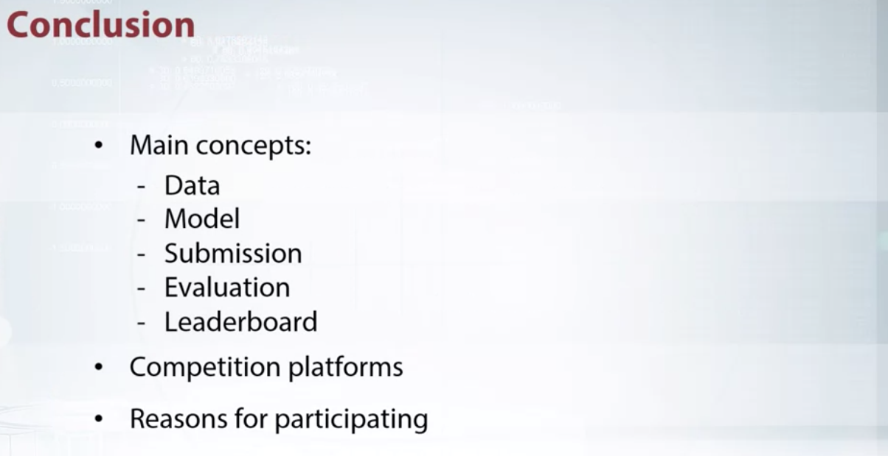

In this video, we analyzed the basic concept of the competition, talked about platforms and reasons for participation. In the next video, we will talk about the difference between real life and competitions.

**Kaggle Overview**

Hi, everyone. In this video we'll learn how to use Kaggle for participation in data science competitions. Let's open kaggle.com. On the Competitions page, we can see a list of currently running competitions. Every competition has a page which consists of title, short description, price budget, number of participating teams, and time before the end. Information involves all previously running competitions, we can find if we click to All. Let's select some challenge and see how it organized.

Here, we see several tabs which we'll explore, and let's start with Overview.

In the Description section we see an introduction provided by organizers. In the Description, there is a short story about company and tasks, sometimes with illustration. At the Evaluation page, we see the description of the target metric. In this challenge, target metric is the Mean Absolute Error between the logarithmic transform predictions and ground truth values. This page also contains example of sample submission file, which is typical for such kind of competitions.

Now let's move to the Prize page.

In the Prize, page we can find information about prizes. Take notice that in the title we have information about the whole money budget, and this page, we see how it will be split among winners.

I want to highlight that in order to get money, you need not only be in top three teams, but also beat a Zillow benchmark model.

Now let's see, Timeline page, which contains all the information about dates. For example, when competition starts, ends, when will the Team Merger deadline and then what month.

All the details about competition, we can find in the Rules. So we need to check really the rules. Here we can find that team limit is three individual, that we have maximum of five submissions per day, that you, for example, should be at least 18 years old to participate. And that, find it, that external data are not allowed. I strongly suggest you to read the rules carefully before joining the competition. And after reading, you should accept it, but I already accepted it.

Now, let's check this, Data.

Here we have data provided by the organizers, several files which we can download, and sample submission among them, and the description of the data. Here we have description of files, description of data fields, and more importantly a description of train and test split. This is quite useful information in order to set up right validation scheme.

If you have any question about data or other questions to ask, or insights to share, you can go to the forum, which we can find under Discussion tab.

Usually it contain a lot of topics or threads, like Welcome, questions about validations, questions about train and test data, and so on and so on.

Every topic have title, number of comments, and number of reports. Let's see some of them. Here we have main message, a lot of comments, in this particular we have only one comments. Each we can up vote or down vote and reply to by click the reply button.

That was a brief overview on forum and now we switch to the Kernels. Usually, I run my code locally, but sometimes it would be handy to check an idea quickly or share code with other participants or teammates. This is what Kernels are for. You can think of Kernel as a small virtual machine in which you write your code, execute it, and share it. Let's take a look at some Kernel, for example for this one.

This show explanatory data analysis on the Zillow competition. It took quite long, contain a lot of pictures, and I believe it very useful.

Here we can see comments for this, different versions. And in order, if you want to make a copy and edit it, we need to Fork this Notebook. It doesn't matter how your predictions were produced, locally or by Kernel, you should submit them through a specialized form. So go back to the competition.

Go to submissions. I already submit sample submission, you can do the same. Click submit predictions, and drag and drop file here. Let's look at my submission.

After submission, you will see it on the leaderboard.

This is my sample submission. Leaderboard contains information about all the teams. So here we have team name or just name in case of single competition team. Score which we produced, number of submissions, time since the last submissions, and position data over seven last days. For example, this means that this guy drops 19 positions during the last week.

That was a brief overview of Kaggle interface. Further, I will tell some extra information about the platform.

So let's move to Overview page at the bottom. And here, we see information about points and tiers. As mentioned here, the competition will be counting towards ranking points an tiers. If you participate, it will be beneficial for your rating.

Sometimes, especially in educational competitions, it's not like that.

Information about Kaggle Progression System we can find if we click this link,

where we can read information about tiers like novice, contributor, master, grandmaster. About medals and ranking points.

This ranking points, I use for global User Ranking. Let's check it.

So, we have user ranking page, and we see all the users ranked, and with links to their profile. Let's check some profile, for example mine. And here we have photo, name, some information, geo information, information about past competitions, medals, and so on. In addition, I want to say a few words about ability to host competition.

Kaggle has this ability. Click Host competition, and there is special Kaggle in class.

At in class, everyone can host their own competition for free and invite people to participate. This option is quite often used in various educational competitions.

So this was a brief overview of Kaggle platform. Thank for your attention.

**Real World Application vs Competitions**

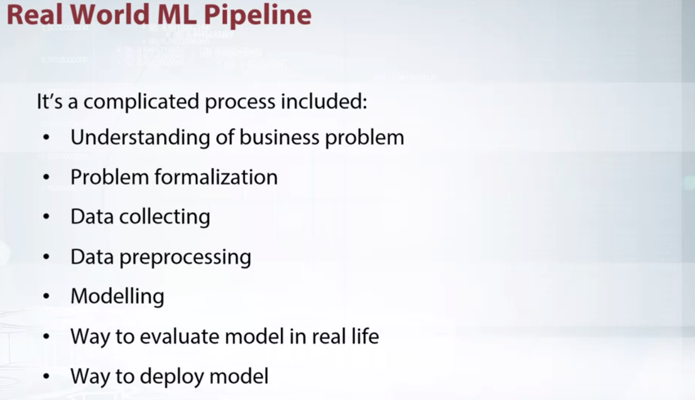

In this video, I want to talk about complexity of real world machine learning pipelines and how they differ from data science competitions. Also, we will discuss the philosophy of the competitions. Real world machine learning problems are very complicated. They include several stages, each of them is very important and require attention. Let's imagine that we need to build an an anti-spam system and consider the basic steps that arise when building such a system. First of all, before doing any machine learning stuff, you need to understand the problem from a business point of view. What do you want to do? For what? How can it help your users? Next, you need to formalize the task. What is the definition of spam? What exactly is to be predicted? The next step is to collect data. You should ask yourself, what data can we use? How to mine examples of spam and non-spam? Next, you need to take care of how to clean your data and pre-process it. After that, you need to move on to building models. To do this, you need to answer the questions, which class of model is appropriate for this particular task? How to measure performance? How to select the best model? The next steps are to check the effectiveness on the model in real scenario, to make sure that it works as expected and there was no bias introduced by learning process. Does the model actually block spam? How often does it block non-spam emails? If everything is fine, then the next step is to deploy the model. Or in other words, make it available to users (tao: meaning of deploy). However, the process doesn't end here. Your need to monitor the model performance and re-train it on new data. In addition, you need to periodically revise your understanding of the problem and go for the cycle again and again.

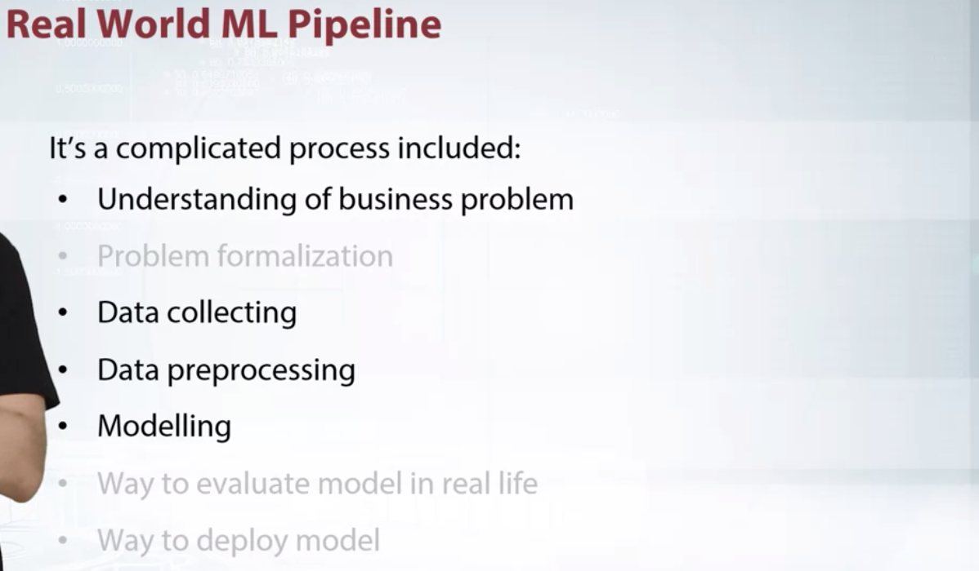

In contrast, in competitions we have a much simpler situation. All things about formalization and evaluation are already done. All data collected and target metrics fixed. Therefore your mainly focus on pre-processing the data, picking models and selecting the best ones. But, sometimes you need to understand the business problem in order to get insights or generate a new feature. Also sometimes organizers allow the usage of external data. In such cases, data collection become a crucial part of the solution.

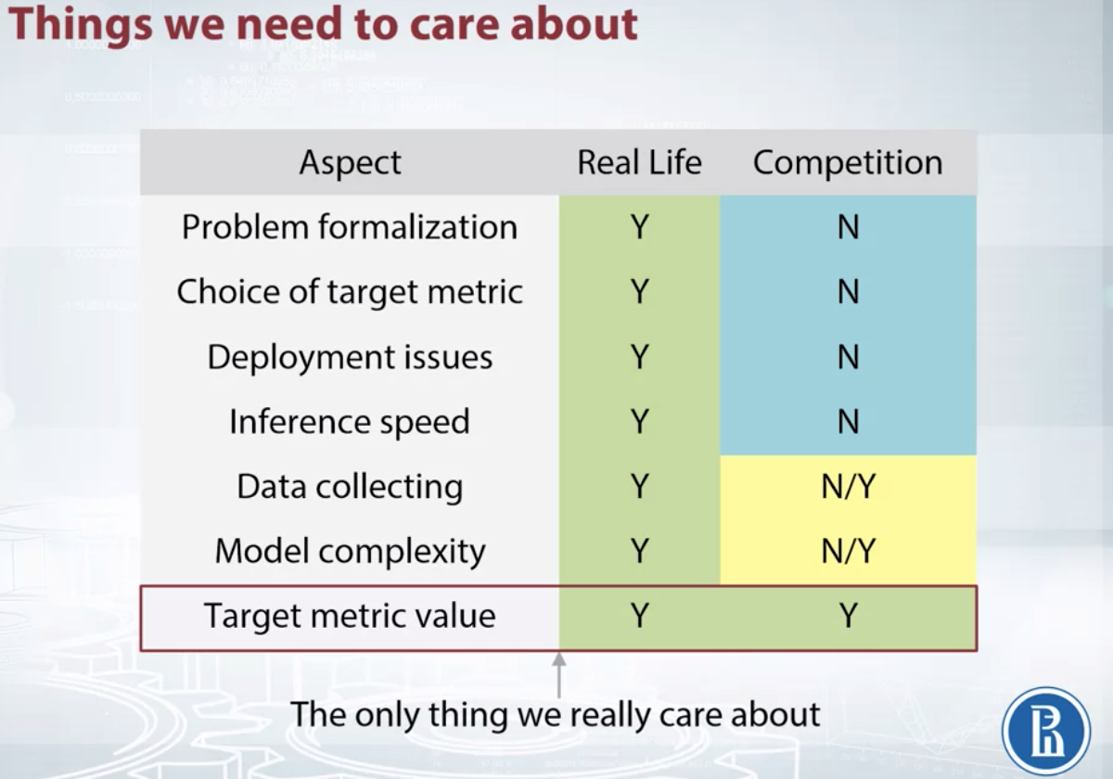

I want to show you the difference between real life applications and competitions more thoroughly. This table shows that competitions are much simpler than real world machine learning problems. The hardest part, problem formalization and choice of target metric, is already done. Also questions related to deploying out of scope, so participants can focus just on modeling part. One may notice that in this table data collection and model complexity roles have no and yes in competition column. The reason for that, that in some competitions you need to take care of these things. But usually it's not the case. I want to emphasize that as competitors, the only thing we should take care about is target metrics value. Speed, complexity and memory consumption, all this doesn't matter as long as you're able to calculate it and re-produce your own results.

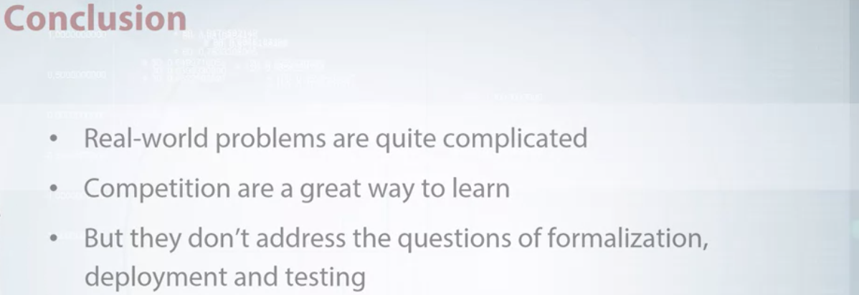

Let's highlight key points. Real world machine learning pipelines are very complicated and consist of many stages. Competitions, add weight to a lot of things about modeling and data analysis, but in general they don't address the questions of formalization, deployment and testing.

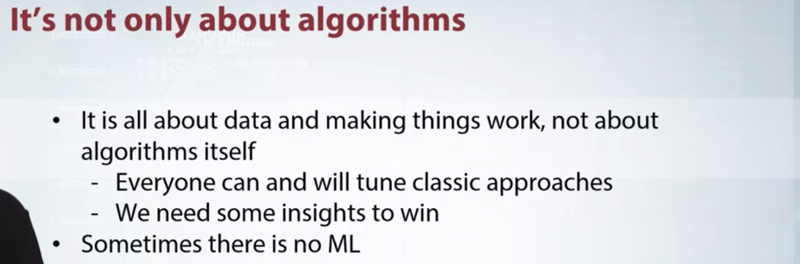

Now, I want to say a few words about philosophy on competitions, in order to form a right impression. We'll cover these ideas in more details later in the course along with examples. The first thing I want to show you is that, machine learning competitions are not only about algorithms. An algorithm is just a tool. Anybody can easily use it. You need something more to win. Insights about data are usually much more useful than a returned ensemble. Some competitions could be solved analytically, without any sophisticated machine learning techniques. In this course, we will show you the importance of understanding your data, tools to use and features you tried to exploit in order to produce the best solution.

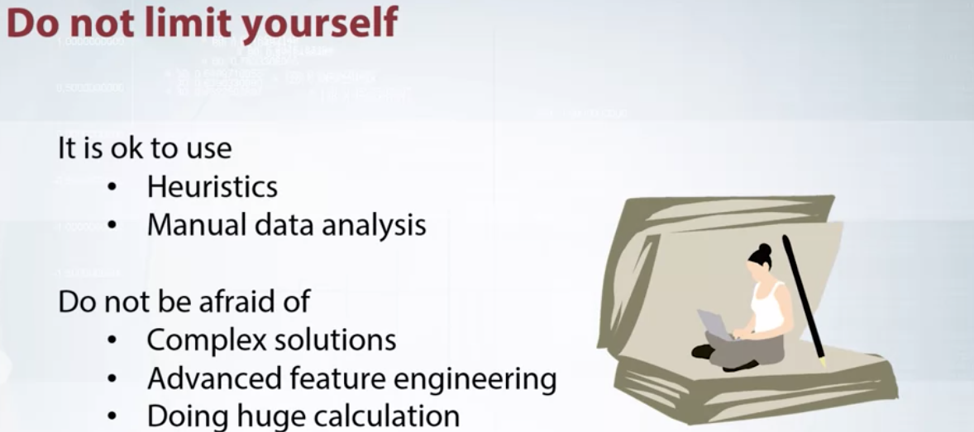

The next thing I want to say, don't limit yourself. Keep in mind that the only thing you should care about is target metric. It's totally fine to use heuristics or manual data analysis in order to construct golden feature and improve your model. Besides, don't be afraid of using complex solutions, advance feature engineering or doing the huge gritty calculation overnights. Use all the ways you can find in order to improve your model. After passing this course, you will able to get the maximum gain from your data.

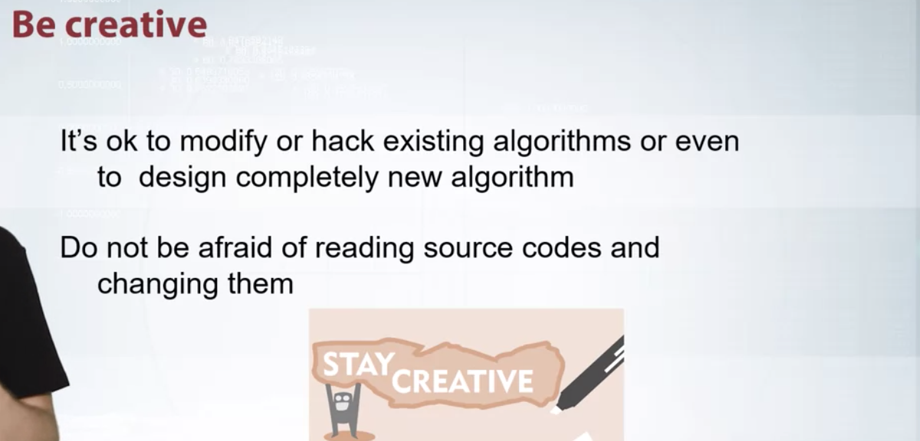

Another important aspect is creativity. You need to know traditional approaches of solid machine learning problems but, you shouldn't be bounded by them. It's okay to modify or hack existing algorithm for your particular task. Don't be afraid to read source codes and change them, especially for deep learning stuff. In our course, we'll show you examples of how a little bit of creativity can lead to constructing golden features or entire approaches for solving problems.

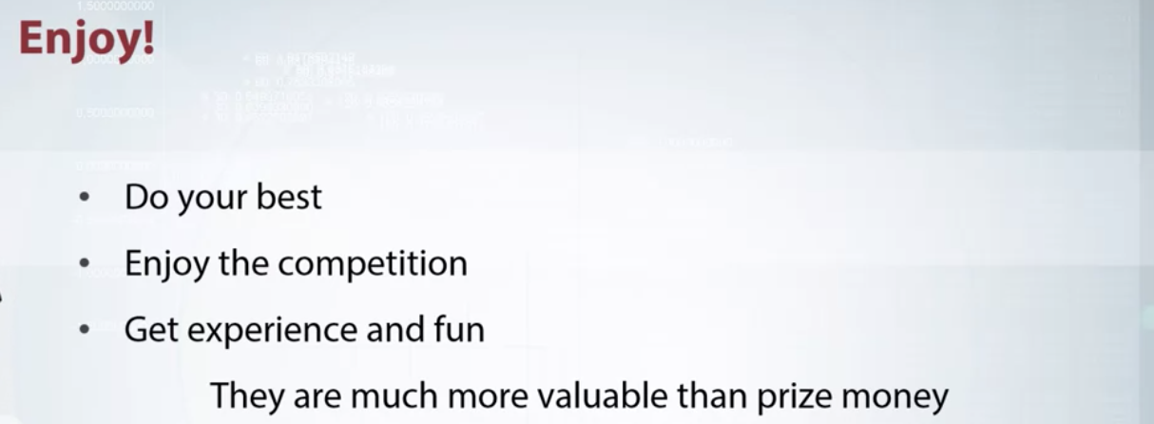

In the end, I want to say enjoy competitions. Don't be obsessed with getting money. Experience and fun you get are much more valuables than the price. Also, networking is another great advantage of participating in data science competition. I hope you find this course interesting.

**Recap of main ML algorithms**

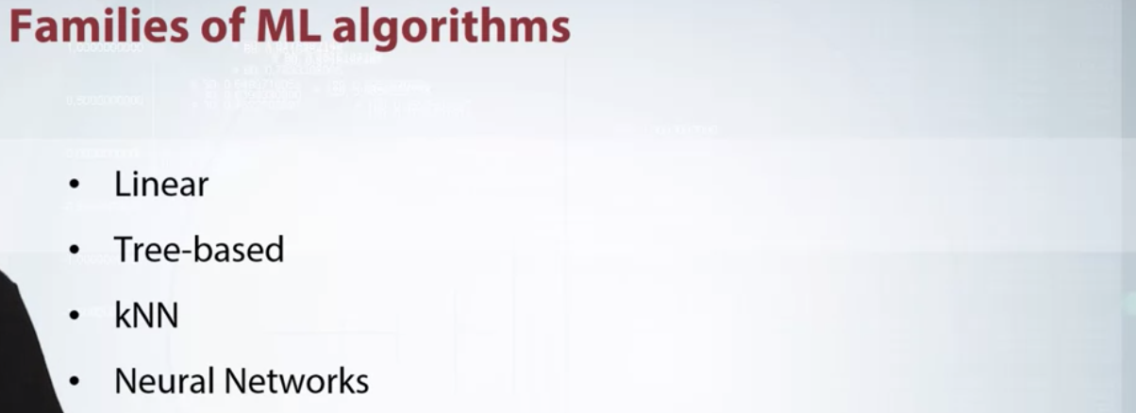

Hi, everyone. In this video, I want to do a brief overview of basic machine learning approaches and ideas behind them. There are several famous of machine learning algorithms which I want to review. It's a Linear Model, Tree-Based Methods, k-Nearest Neighbors, and Neural Nets. For each of this family, I will give a short intuitive explanation with examples. If you don't remember any of these topics, I strongly encourage you to learn it using links from additional materials.

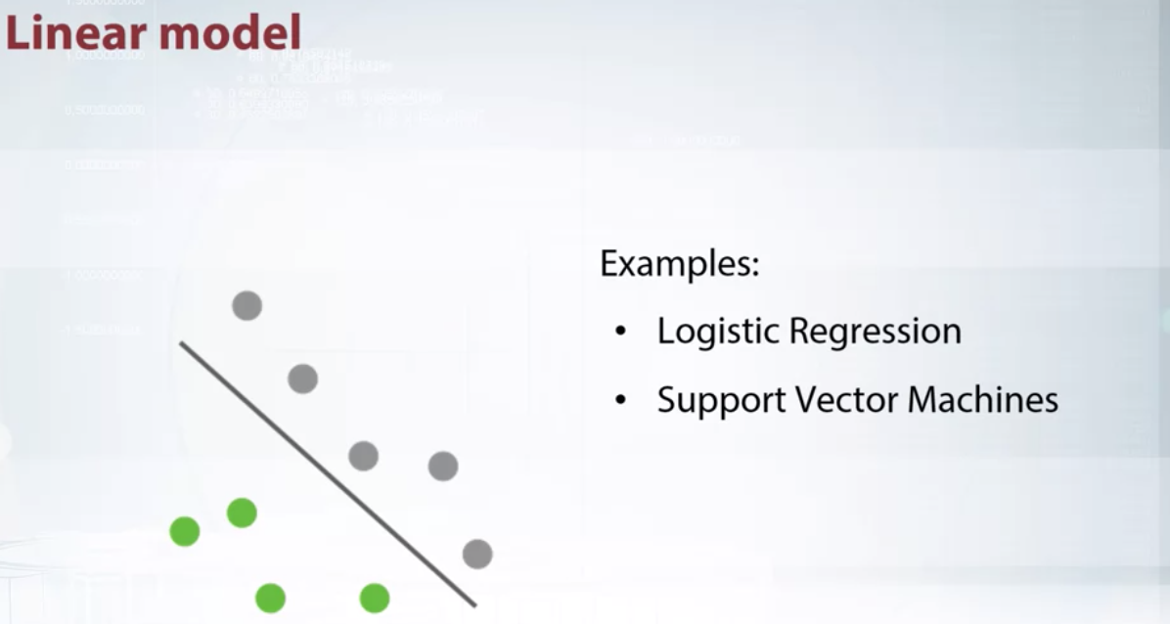

Let's start with Linear Models. Imagine that we have two sets of points, gray points belong to one class and green ones to another. It is very intuitive to separate them with a line. In this case, it's quite simple to do since we have only two dimensional points. But this approach can be generalized for a high dimensional space. This is the main idea behind Linear Models. They try to separate objects with a plane which divides space into two parts. You can remember several examples from this model class like Logistic Regression or SVM (Tao does not think SVM is linear model, because of the kernel transformations). They all are Linear Models with different loss functions. I want to emphasize that Linear Models are especially good for sparse high dimensional data.

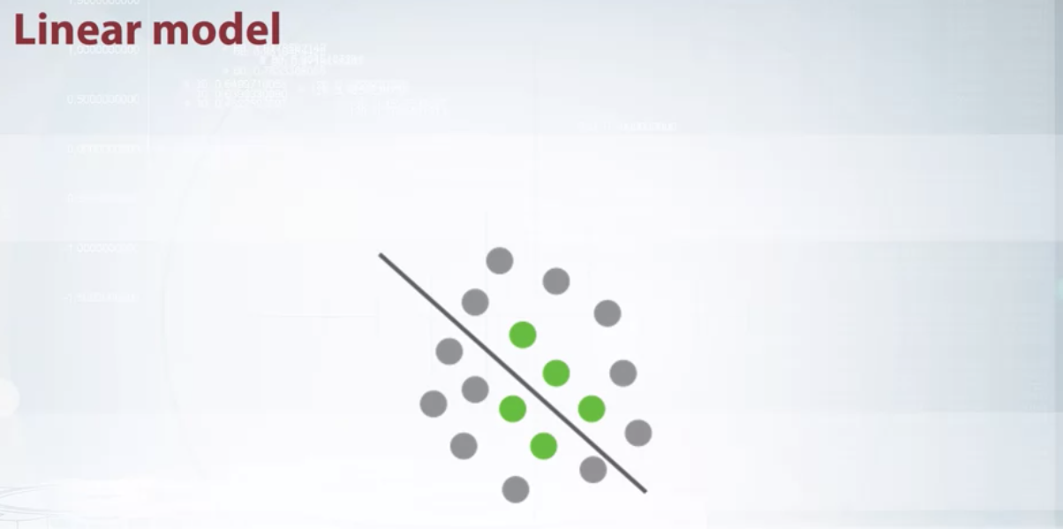

But you should keep in mind the limitations of Linear Models. Often, point cannot be separated by such a simple approach. As an example, you can imagine two sets of points that form rings, one inside the other. Although it's pretty obvious how to separate them, Linear Models are not an appropriate choice either and will fail in this case.

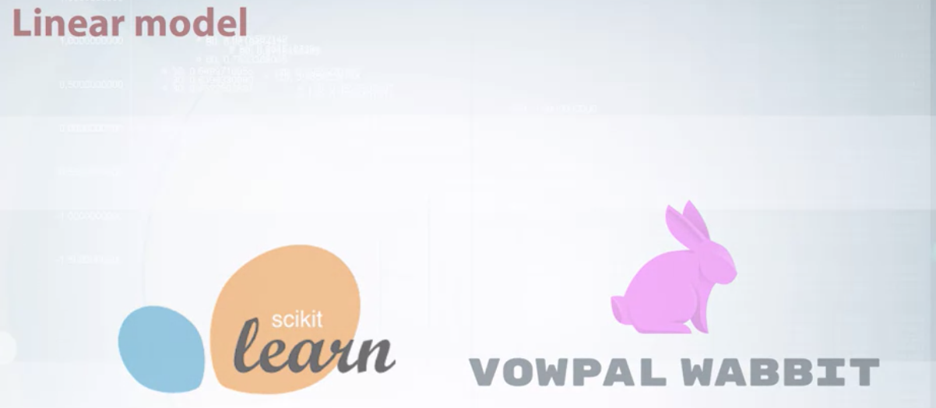

You can find implementations of Linear Models in almost every machine learning library. Most known implementation in Scikit-Learn library. Another implementation which deserves our attention is Vowpal Wabbit, because it is designed to handle really large data sets.

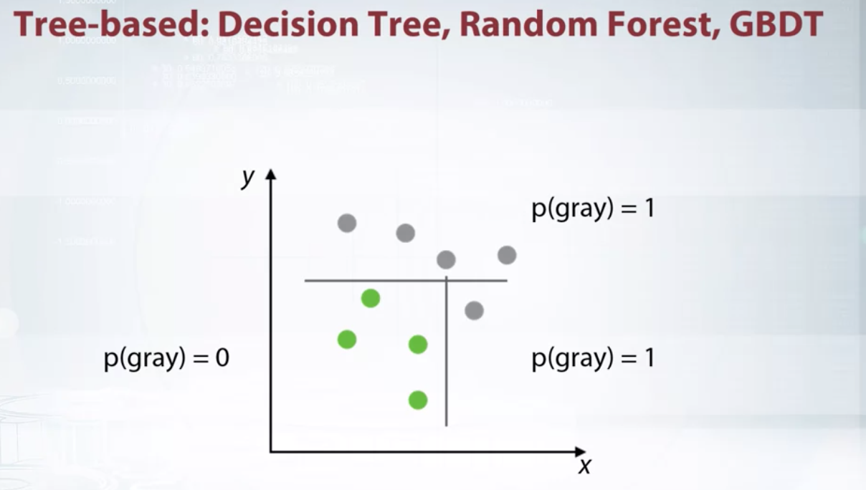

We're finished with Linear Model here and move on to the next family, Tree-Based Methods. Tree-Based Methods use decision tree as a basic block for building more complicated models. Let's consider an example of how decision tree works. Imagine that we have two sets of points similar to a linear case. Let's separate one class from the other by a line parallel to the one of the axes. We use such restrictions as it significantly reduces the number of possible lines and allows us to describe the line in a simple way. After setting the split as shown at that picture, we will get two sub spaces, upper will have probability of gray=1, and lower will have probability of gray=0.2. Upper sub-space doesn't require any further splitting. Let's continue splitting for the lower sub-space. Now, we have zero probability on gray for the left sub-space and one for the right. This was a brief overview of how decision tree works. It uses divide-and-conquer approach to recur sub-split spaces into sub-spaces. Intuitively, single decision tree can be imagined as dividing space into boxes and approximating data with a constant inside of these boxes. The way of true axis splits and corresponding constants produces several approaches for building decision trees. Moreover, such trees can be combined together in a lot of ways. All this leads to a wide variety of tree-based algorithms, most famous of them being Random Forest and Gradient Boosted Decision Trees (GBDT). In case if you don't know what are that, I strongly encourage you to remember these topics using links from additional materials. In general, tree-based models are very powerful and can be a good default method for tabular data. In almost every competitions, winners use this approach. But keep in mind that for Tree-Based Methods, it's hard to capture linear dependencies since it requires a lot of splits.

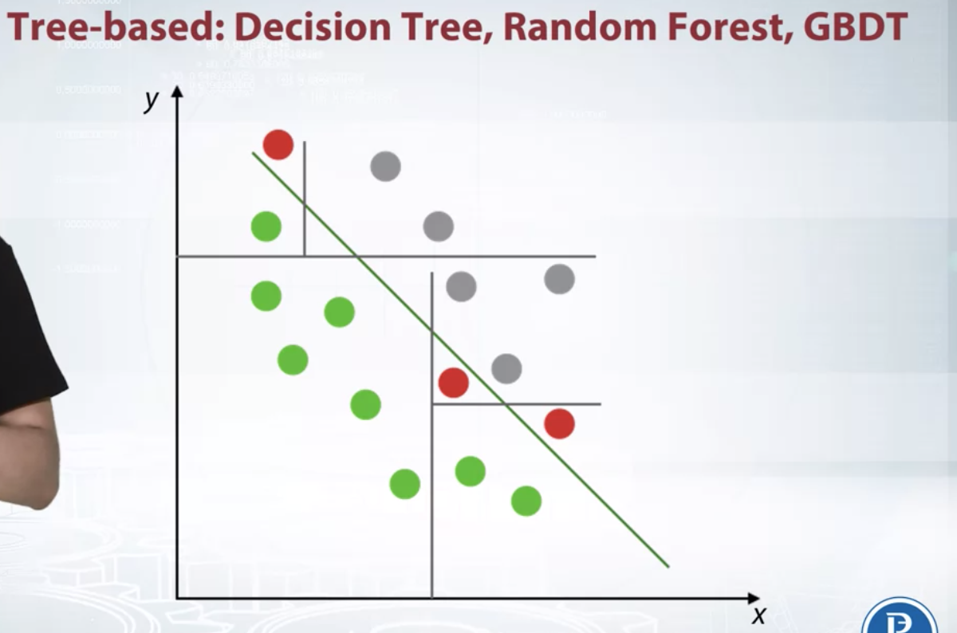

We can imagine two sets of points which can be separated with a line. In this case, we need to grow a tree with a lot of splits in order to separate points. Even in such case, our tree could be inaccurate near decision border, as shown on the picture.

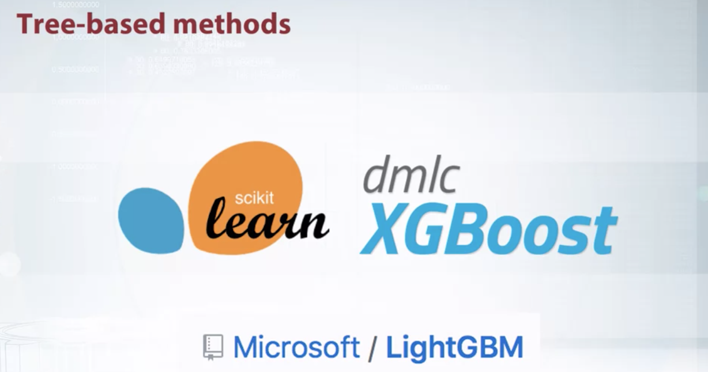

Similar to Linear Models, you can find implementations of tree-based models in almost every machine learning library. Scikit-Learn contains quite good implementation of random forest which I personally prefer. Although Scikit-Learn contain implementation of gradient boost decision trees. I prefer to use libraries like XGBoost and LightGBM for their higher speed and accuracy.

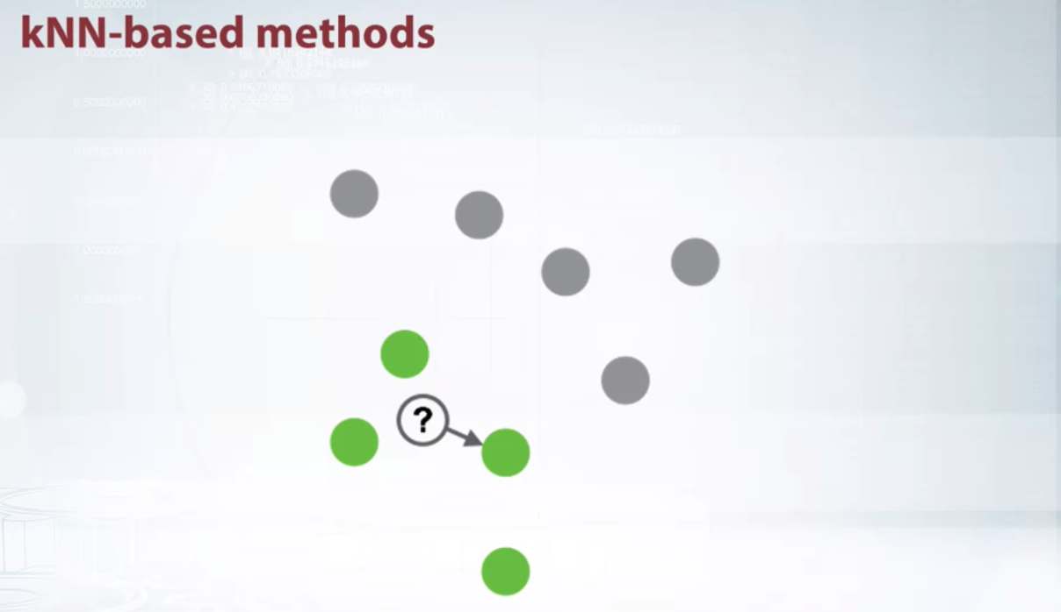

So, here we end the overview of Tree-Based Methods and move on to the k-NN. Before I start the explanation, I want to say that k-NN is abbreviation for k-Nearest Neighbors. One shouldn't mix it up with Neural Networks. So, let's take a look at the familiar binary classification problem. Imagine that we need to predict label for the points shown with question mark at this slide. We assume that points close to each other are likely to have similar labels. So, we need to find the closest point which displayed by arrow and pick its label as an answer. This is how nearest neighbor's method generally works. It can be easily generalized for k-NN, if we will find k-nearest objects and select plus labeled by majority vote. The intuition behind k-NN is very simple. Closer objects will likely to have same labels. In this particular example, we use square distance to find the closest object. In general case, it can be meaningless to use such a distance function. For example, square distance over images is unable to capture semantic meaning. Despite simplicity of the approach, features based on nearest neighbors are often very informative. We will discuss them in more details later in our course.

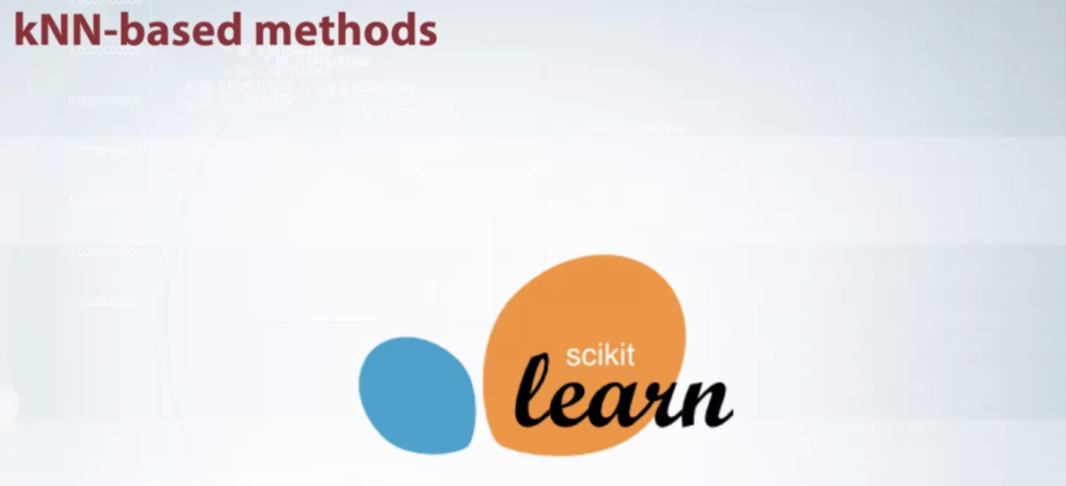

Implementations of k-NN can be found in a lot of machine learning libraries. I suggest you to use implementation from Scikit-Learn since it use algorithm matrix to speedup recollections and allows you to use several predefined distance functions. Also, it allows you to implement your own distance function.

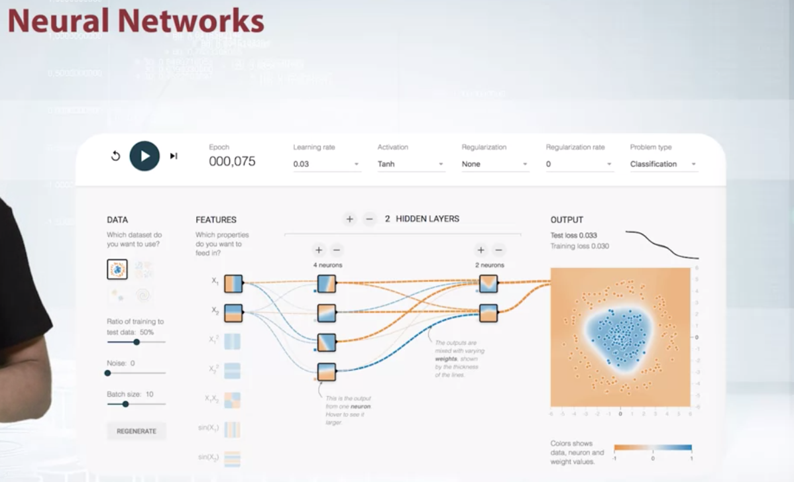

The next big class of model I want to overview is Neural Networks. Neural Nets is a special class of machine learning models, which deserve a separate topic. In general, such methods can be seen in this Black-Box which produce a smooth separating curve in contrast to decision trees. I encourage you to visit TensorFlow playground which is shown on the slide, and play with different parameters of the simple feed-forward network in order to get some intuition about how feed-forward Neural Nets works. Some types of Neural Nets are especially good for images, sounds, text, and sequences. We won't cover details of Neural Nets in this course.

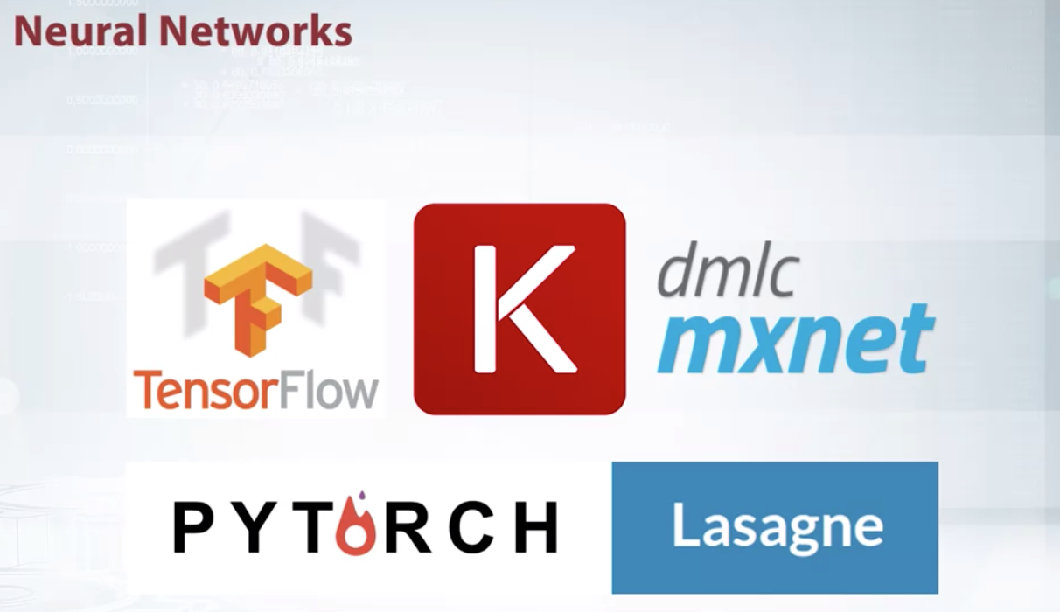

Since Neural Nets attracted a lot of attention over the last few years, there are a lot of frameworks to work with them. Packages like TensorFlow, Keras, MXNet, PyTorch, and Lasagne can be used to feed Neural Nets. I personally prefer PyTorch since it's provides flexible and user-friendly way to define complex networks.

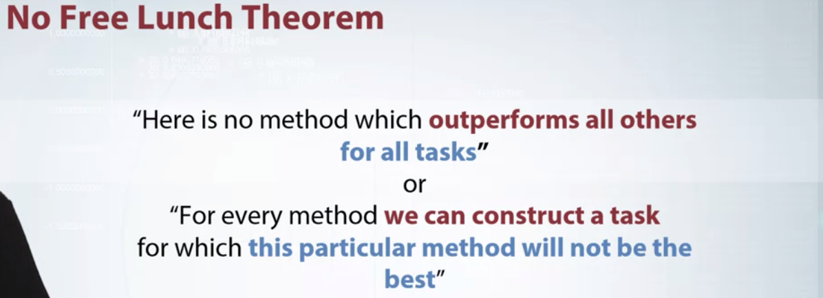

After this brief recap, I want to say a few words about No Free Lunch Theorem. Basically, No Free Lunch Theorem states that there is no methods which outperform all others on all tasks, or in other words, for every method, we can construct a task for which this particular method will not be the best. The reason for that is that every method relies on some assumptions about data or task. If these assumptions fail, Limited will perform poorly. For us, this means that we cannot every competition with just a single algorithm. So we need to have a variety of tools based off different assumptions.

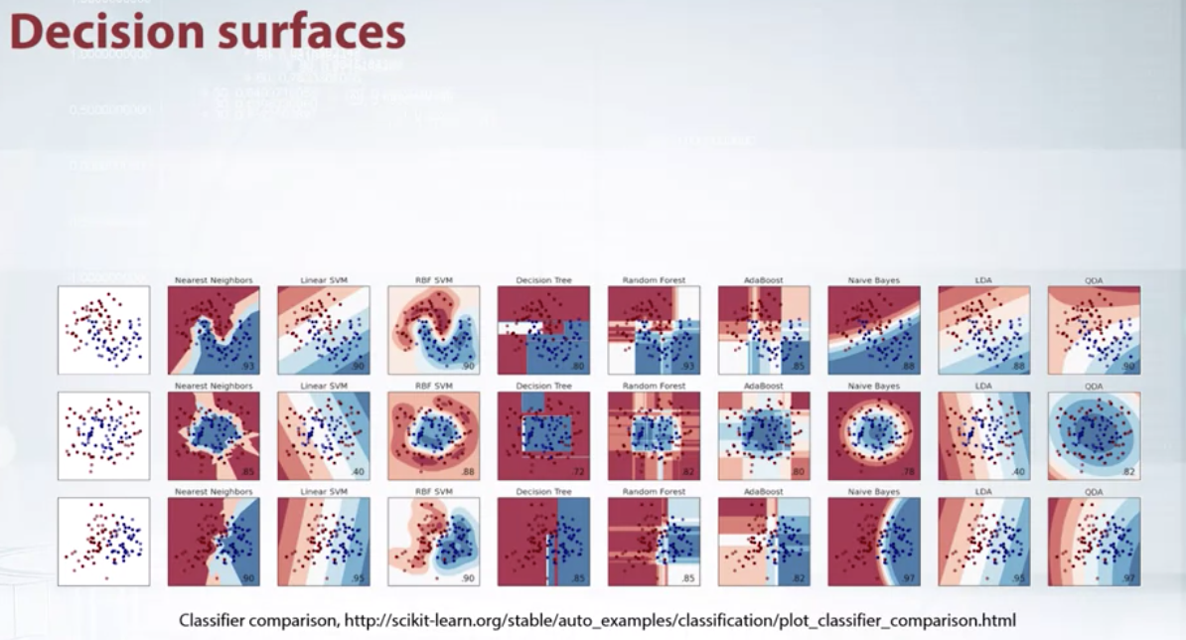

Before the end of this video, I want to show you an example from Scikit-Learn library, which plots decision surfaces for different classifiers. We can see the type of algorithm have a significant influence of decision boundaries and consequently on [inaudible]. I strongly suggest you to dive deeper into this example and make sure that you have intuition why these classifiers produce such surfaces.

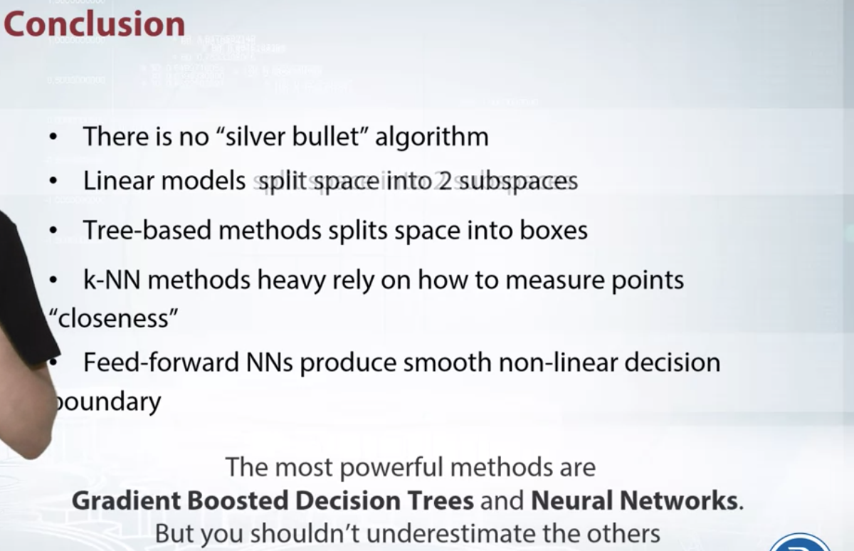

In the end, I want to remind you the main points of this video. First of all, there is no silver bullet algorithm which outperforms all the other in all and every task. Next, is that Linear Model can be imagined as splitting space into two sub-spaces separated by a hyper plane. Tree-Based Methods split space into boxes and use constant the predictions in every box. k-NN methods are based on the assumptions that close objects are likely to have same labels. So we need to find closest objects and pick their labels. Also, k-NN approach heavily relies on how to measure point closeness. Feed-forward Neural Nets are harder to interpret but they produce smooth non-linear decision boundary. The most powerful methods are Gradient Boosted Decision Trees and Neural Networks. But we shouldn't underestimate Linear Models and k-NN because sometimes, they may be better. We will show you relevant examples later in our course. Thank you for your attention.

Will performance of GBDT model drop dramatically if we remove the first tree?

Following the quiz question in this notebook we will do a little "how *Gradient Boosting* works" and find out answer for the question: "Will performance of GBDT model drop dramatically if we remove the first tree?'.

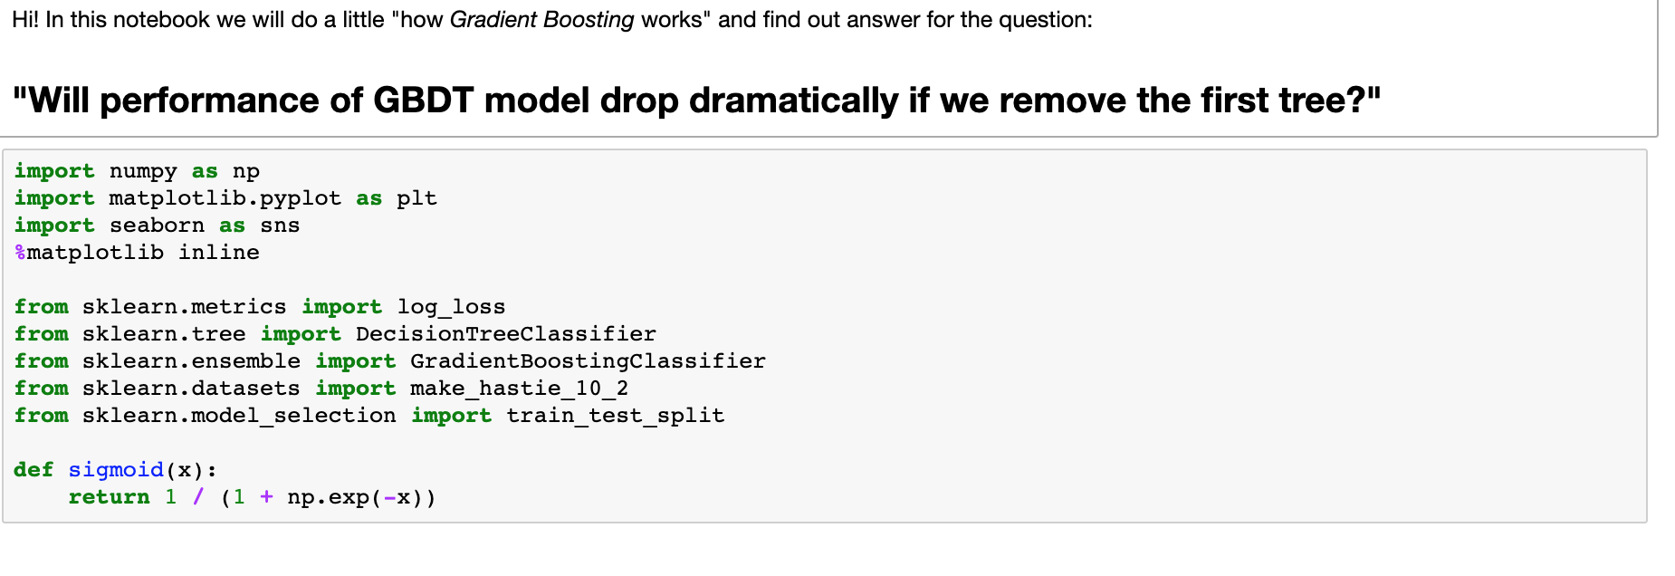

Tao: in the following, X_all = np.random.randn(5000, 1) generates a matrix with 5000 rows and 1 column.

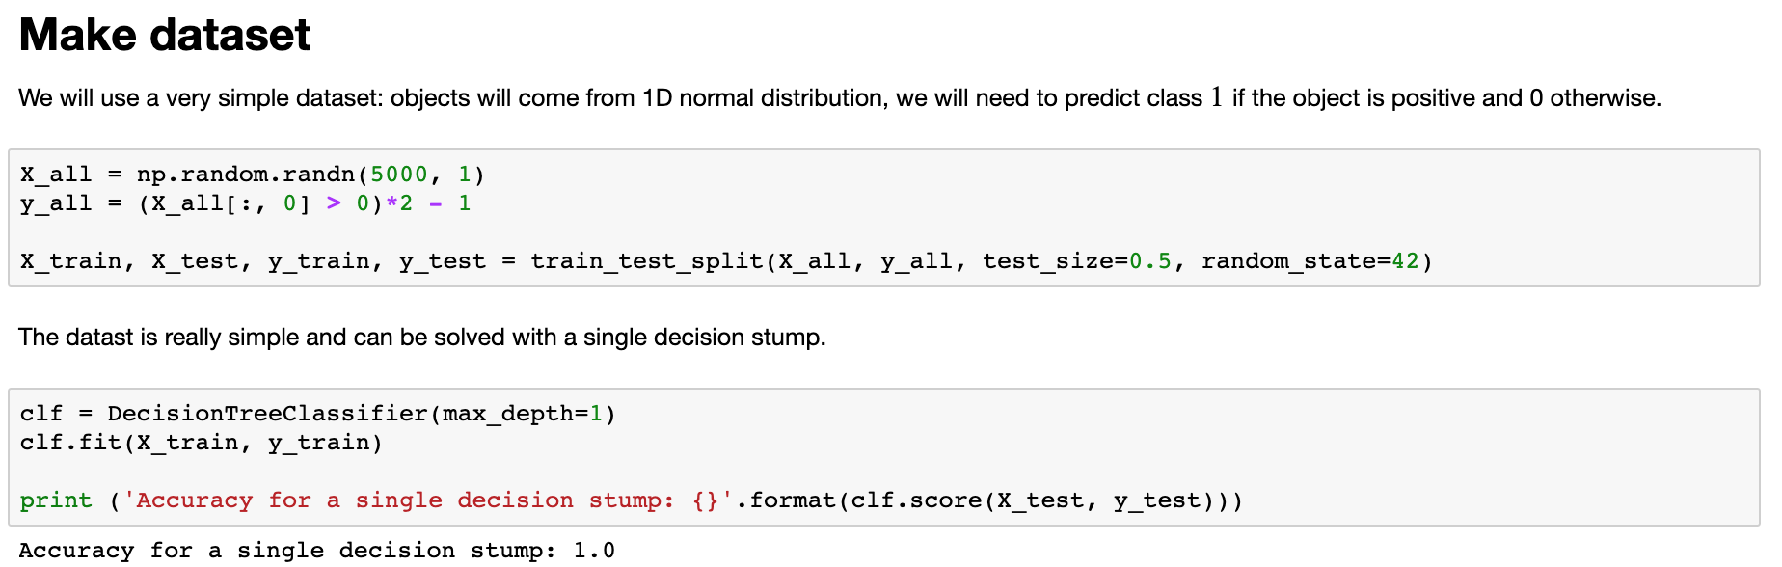

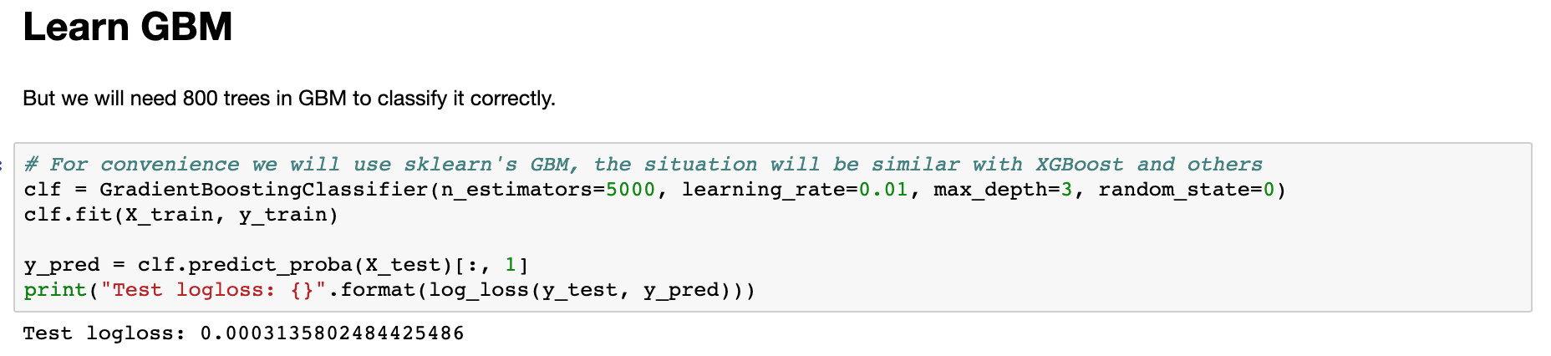

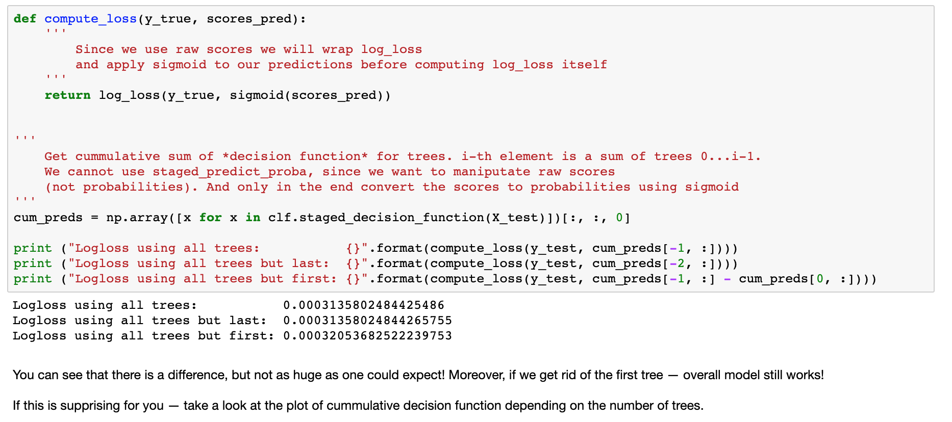

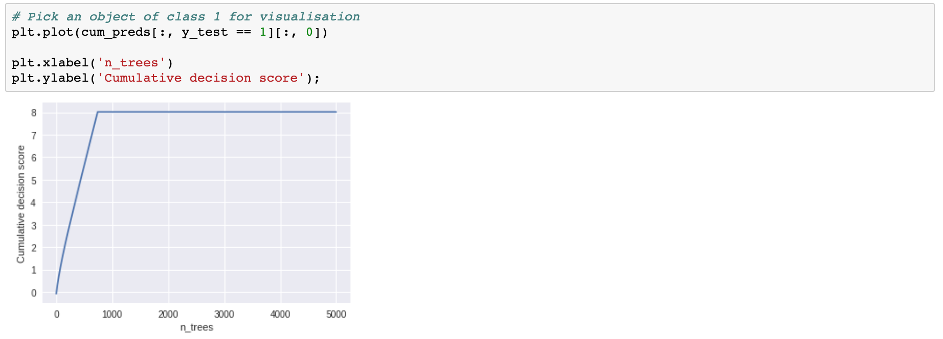

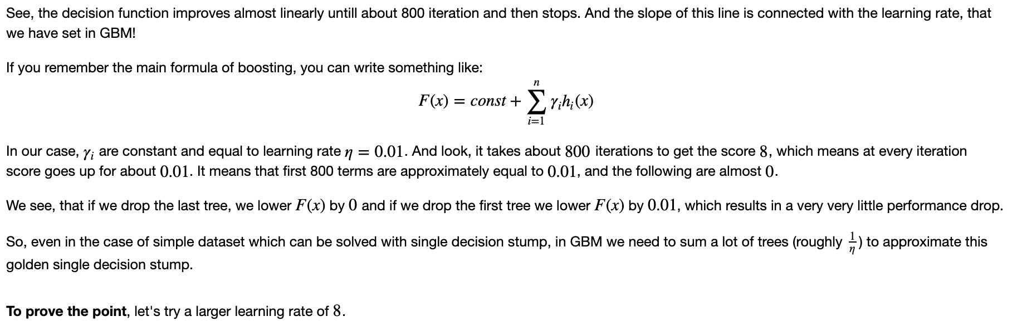

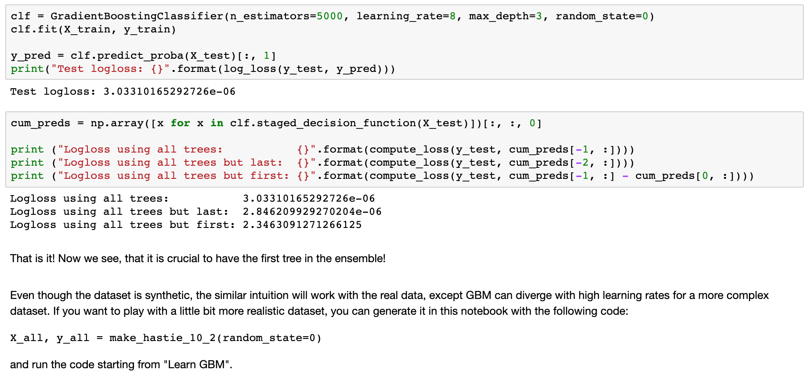

**Software/Hardware Requirements**

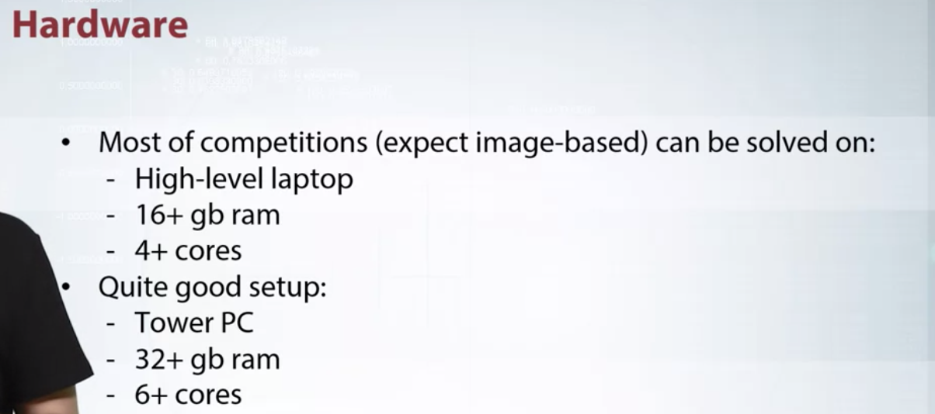

Hi, everyone. In this video, I want to do an overview of hardware and software requirements. You will know what is typical stuff for data science competitions. I want to start from hardware related things. Participating in competitions, you generally don't need a lot of computation resources. A lot of competitions, except imaged based, have under several gigabytes of data. It's not very huge and can be processed on a high level laptop with 16 gigabyte RAM and 4 physical cores.

Quite a good setup is a tower PC with 32 gigabyte of ram and six physical cores, this is what I personally use.

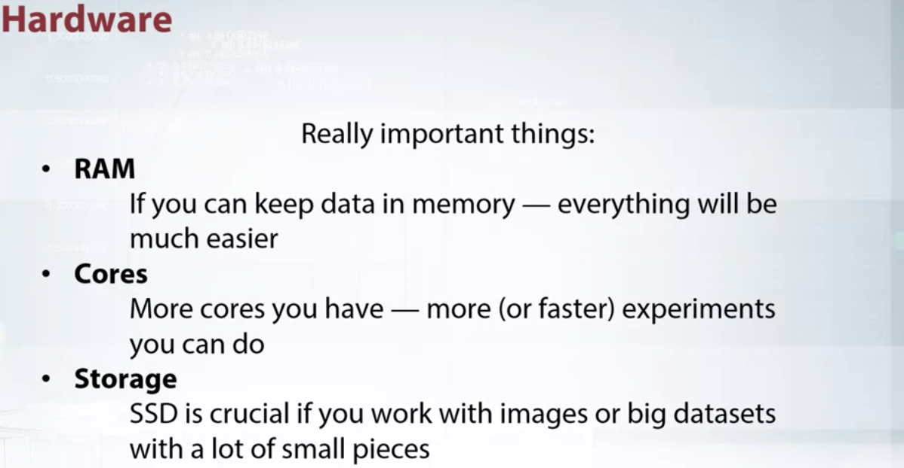

You have a choice of hardware to use. I suggest you to pay attention to the following things. First is RAM, for this more is better. If you can keep your data in memory, your life will be much, much easier. Personally, I found 64 gigabytes is quite enough, but some programmers prefer to have 128 gigabytes or even more.

Next are cores, the more core you have the more or faster experiments you can do. I find it comfortable to work with fixed cores, but sometimes even 32 are not enough.

Next thing to pay attention for is storage. If you work with large datasets that don't fit into the memory, it's crucial to have fast disk to read and write chunks of data. SSD is especially important if you train Neural Networks or large number of images.

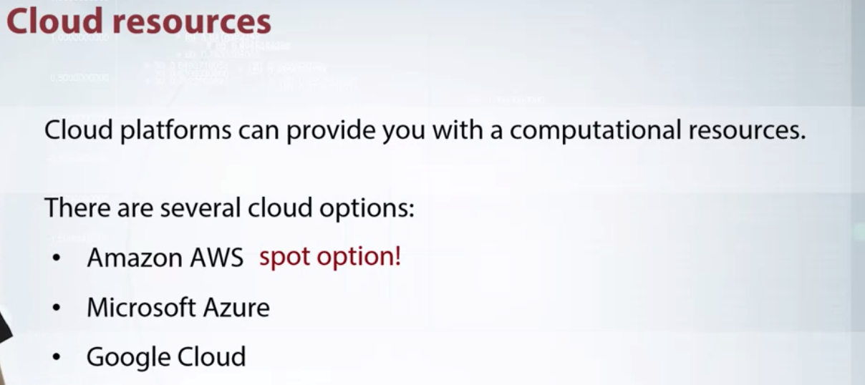

In case you really need computational resources. For example, if you are part of team or have a computational heavy approach, you can rent it on cloud platforms. They offer machines with a lot of RAMs, cores, and GPUs. There are several cloud providers, most famous are Amazon AWS, Microsoft's Azure, and Google Cloud. Each one has its own pricing, so we can choose which one best fits your needs and budget. I especially want to draw your attention to AWS spot option. Spot instances enable you to be able to use instance, which can lower your cost significantly. The higher your price for spot instance is set by Amazon and fluctuates depending on supply and demand for spot instances. Your spot instance run whenever you bid exceeds the current market price. Generally, it's much cheaper than other options. But you always have risk that your bid will get under current market price, and your source will be terminated.

Tutorials about how to setup and configure cloud resources you may find in additional materials.

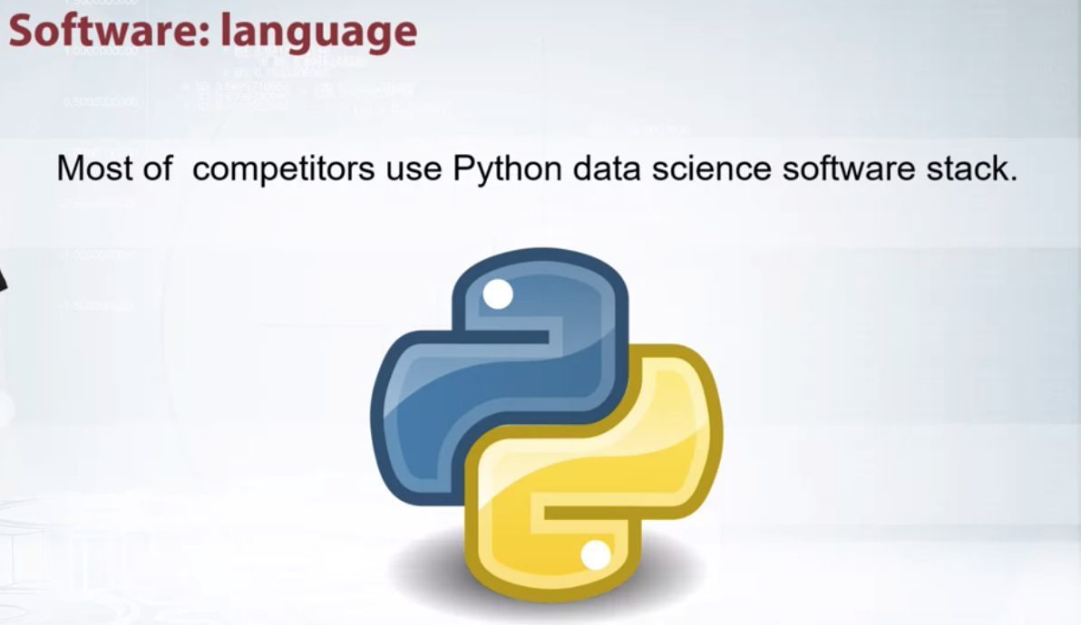

Another important thing I want to discuss is software. Usually, rules in competitions prohibit to use commercial software, since it requires to buy a license to reproduce results. Some competitors prefer R as basic language. But we will describe Python's tech as more common and more general.

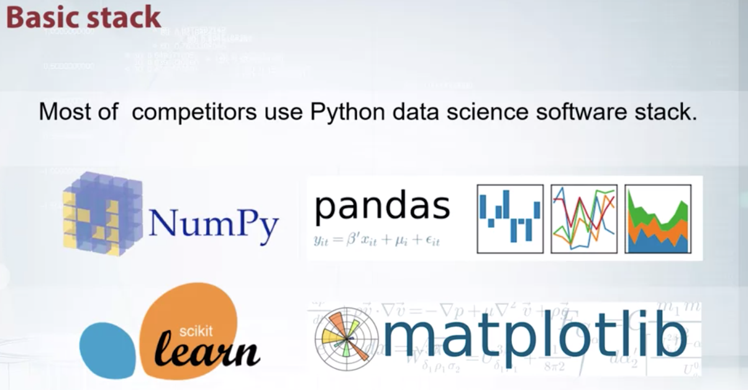

Python is quite a good language for fast prototyping. It has a huge amount of high quality and open source libraries. And I want to reuse several of them.

Let's start with NumPy. It's a linear algebra library to work with n dimensional arrays, which contains useful linear algebra routines and random number capabilities.

Pandas is a library providing fast, flexible, and expressive way to work with a relational or table of data, both easily and intuitive. It allows you to process your data in a way similar to SQL. Scikit-learn is a library of classic machine learning algorithms. It features various classification, regression, and clustering algorithms, including support virtual machines, random force, and a lot more.

Matplotlib is a plotting library. It allows you to do a variety of visualization, like line plots, histograms, scatter plots and a lot more.



As IDE, I suggest you to use IPython with Jupyter node box, since they allow you to work interactively and remotely. The last property is especially useful if you use cloud resources.

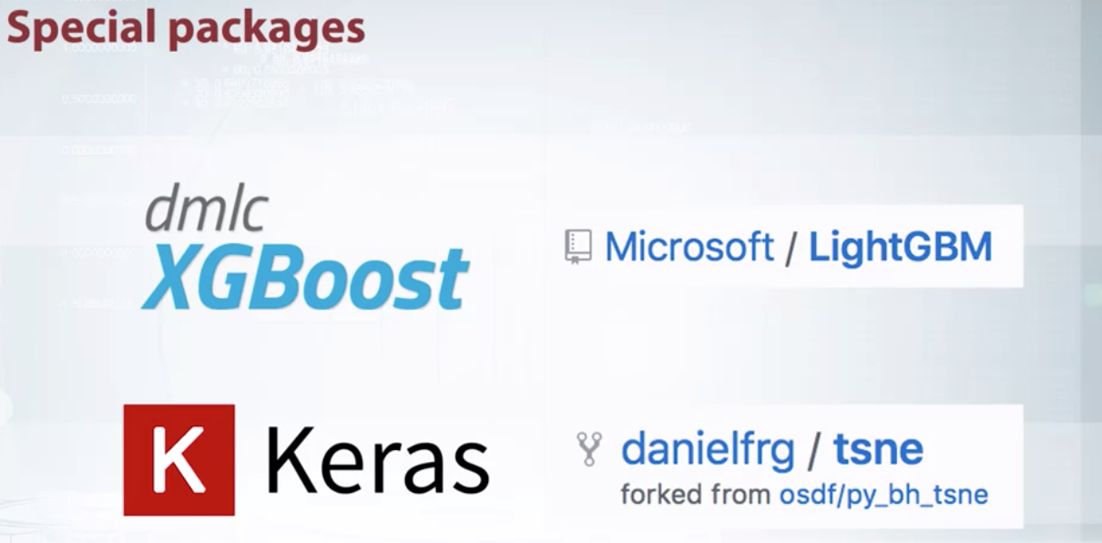

Additional packages contain implementation of more specific tools. Usually, single packages implement single algorithm. XGBoost and LightGBM packages implement gradient-boosted decision trees in a very efficient and optimized way. You definitely should know about such tools. Keras is a user-friendly framework for neural nets. tsne package is an efficient implementation of tsne projection method which we will discuss in our course.

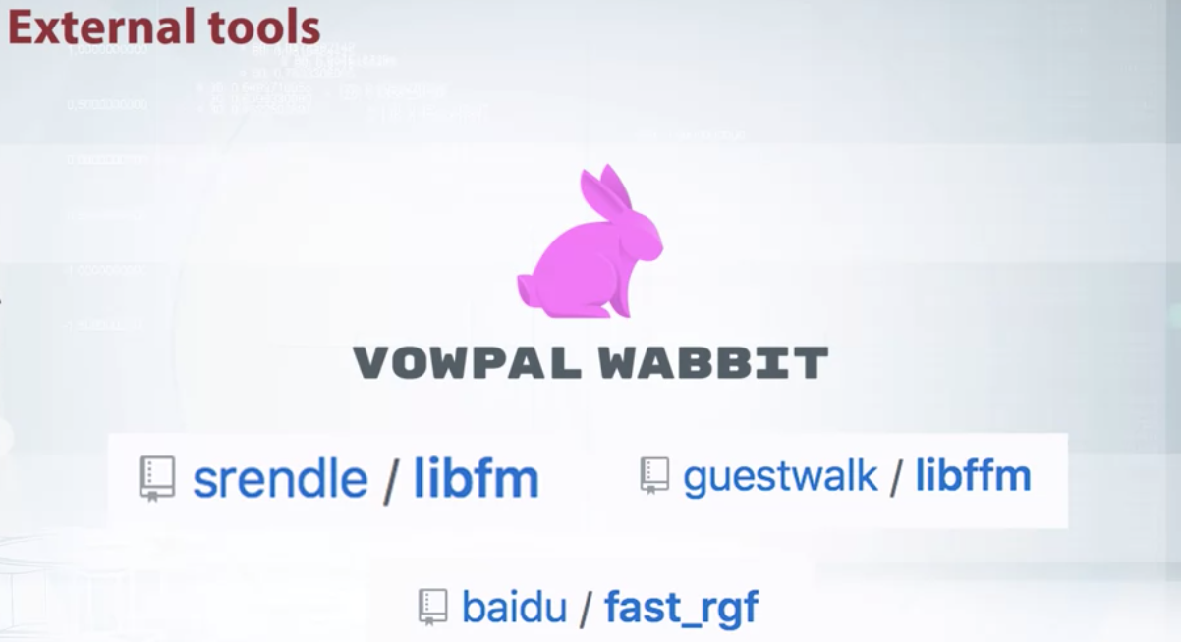

Also, I want to say a few words about external tools which usually don't have any connection despite, but still very used for computations. One such tool is Vowpal Wabbit. It is a tool designed to provide blazing speed and handle really large data sets, which don't fit into memory. Libfm and libffm implement different types of optimization machines, and often used for sparse data like click-through rate prediction. Rgf is an alternative base method, which I suggest you to use in ensembles.

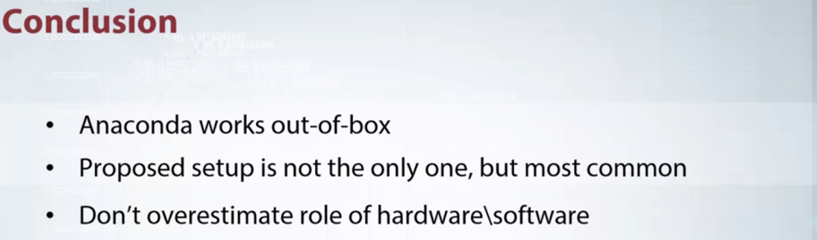

You can install these packages one by one. But as alternative, you can use Python distribution like Anaconda, which already contains a lot of mentioned packages. And then, through this video, I want to emphasize the proposed setup is the most common but not the only one. Don't overestimate the role of hardware and software, since they are just tools. Thank you for your attention.

Stopa: Programming Assignment: Pandas basics